GEOPHYSICAL RESEARCH LETTERS
Supporting Information for
Seismological Evidence of Multiple Crustal Magma Reservoirs Beneath Mt. Wrangell in Southcentral Alaska
Qili Andy Dai^{*1}, Haiying Gao¹, Sahria Nayon¹, Zane Cleghorn¹, Cong Li²
¹Department of Earth, Geographic, and Climate Sciences, University of Massachusetts Amherst, Amherst, MA, USA
²Department of Geosciences, University of Arizona, Tucson, AZ, USA

Contents of this file

Text S1
Figures S1 to S13
Tables S1 to S4

Introduction
This supplementary file contains additional text, figures and tables to support the main text, including receiver function analysis, synthetic tests, earthquake distribution, receiver functions for each station, harmonic decomposition terms, neighborhood algorithm searching progress, and melt fraction estimation.

Text S1
Receiver Function Analysis
We analyze three-component seismic waveforms recorded at stations AV.WACK and AV.WAZA for teleseismic events occurring between 2016 and 2024. The earthquakes are required to have a body-wave magnitude ≥ 5.3 and an epicentral distance of 30°–95° from each station (Figure S1). For each event, we extract waveforms spanning 30 seconds before to 60 seconds after the predicted direct P-wave arrivals calculated based on the IASP91 model (Kennett & Engdahl, 1991). The data are detrended, resampled to 20 points per second, and the horizontal components are rotated to radial and transverse orientations. We then calculate radial- and transverse-component RFs of P-to-S conversions using frequency-domain water-level deconvolution, applying a 2 Hz low-pass Gaussian filter (Ammon, 1991; Li et al., 2018; Liu & Gao, 2023).
Observed RFs are band-pass filtered at 0.05–1.5 Hz to remove low-frequency noise, followed by a three-step procedure is applied to the data quality screening of observed radial-component RFs (Li et al., 2018; Liu & Gao, 2023). First, we require the minimum signal-to-noise ratio of the radial-component RFs equal to or greater than 5. The P-to-S converted signal is defined as the maximum positive amplitude within the time window of 2.0–7.0 s after the IASP91-predicted direct P-wave arrival time, while the noise is the standard deviation of the 2.0–10.0 s waveforms prior to the P-wave arrival. Second, we assess the coherence of the P-to-S conversions of the radial-component RFs across similar back-azimuthal ranges, discarding RFs events that showing anomalous significant deviations from the expected patterns. For example, when the majority of RFs exhibit a clear positive signal between 4.8–5.5 s within the back-azimuthal range of 243°–244°, those RFs that don’t display this feature are excluded for further analysis (Figure S2). Third, we evaluate the stability of Moho- and intra-crustal-converted phases across three frequency bands (0.25–0.75 Hz, 0.1–1.0 Hz, and 0.2–1.2 Hz), discarding RFs that are inconsistent across bands. For instance, we remove the RF trace if a converted phase is only identifiable within one frequency band but absent in the others. After applying these criteria, we retain 549 RFs at AV.WACK (Figure 2a; Figures S3 and S4) and 223 at AV.WAZA (Figure 2; Figure S5).

Receiver Function Modeling and Synthetic Tests
Selection of the initial reference model is important for RF modeling and inversion. While RF analysis constrains the depth and sharpness of velocity discontinuities, it doesn’t provide absolute seismic velocities. We start with forward modeling using several published velocity models, including Berg et al. (2020), Yang & Gao (2020), and Liu & Gao (2025). From each model, we extract the 1D velocity profiles beneath the two seismic stations. Because tomography generally resolves smooth velocity variations, we subdivide each profile into multiple crustal layers and introduce a velocity discontinuity at Vs=4.2 km/s to represent the Moho. However, due to the absence of anisotropy, dipping interfaces, and other possible discontinuities in the velocity profiles, the synthetic RFs fail to reproduce the variation patterns of the observed RFs with respect to backazimuth. In addition, several prominent phases present in the observed RFs are not predicted. Therefore, we construct our initial models based on the results of harmonic decomposition analysis, in combination with the Yang & Gao (2020) model. The model of Yang & Gao (2020) was developed using full-wave ambient noise propagation simulation and inversion, providing more reliable constraints on absolute shear-wave velocities.
We quantitatively compare the Moho depths obtained in this study with those reported in previous studies, including Zhang et al. (2019), Gama et al. (2022), and Liu & Gao (2023) (Table S3). On average, the Moho depths estimated here are approximately 8 km shallower than previous estimates. While many factors can contribute to uncertainties in Moho depth estimates, we attribute this discrepancy primarily to the presence of low-velocity lower crustal layers beneath the two stations. Such low-velocity layers can significantly delay the P_{m}s arrivals, leading to systematic overestimation of the Moho depth if they are not considered in the reference model.
Side-lobe artifacts and reverberations present in the observed RFs cannot be fully reproduced by the modeling method we use, which can potentially affect the amplitudes of the converted phases. To assess their impact, we carried out a series of comparative tests examining (1) the influence of side lobes and (2) the effect of multiples generated from the shallower low-velocity layer on the signals near the Moho (Figures S10 and S11; Table S4). The Crust1.0 model (Laske et al. 2013) indicates a sedimentary layer of ~100 m in the study area, whose effect is negligible for this study and thus omitted.

Side-lobe artifacts
We generated synthetic RFs using Model 1 in Table S4. We applied a 0.05–1.5 Hz band-pass filter to the synthetic RFs and compare them with the unfiltered synthetics. The results show that the side lobes of the P_{m}s converted phase reach amplitudes of ~10% of the P_{m}s signal (Figure S10). Therefore, we use this value as the threshold to distinguish side-lobe artifacts from true signals in the observed receiver functions.
Additionally, we compared the synthetic RFs generated from our final models before and after filtering, which show very similar patterns (Figure S10). This comparison indicates that the phases of interest originate from true features, although side lobes may add constructively to them.
Furthermore, we applied multiple band-pass filters to the observed receiver functions and found that these negative phases are consistently present. For example, at station AV.WACK, the negative phase at ~4.0 s has an amplitude comparable to the P_{m}s phase at ~5.0 s, confirming that the observed phases are far more significant than any side-lobe effect.

Addition of background noise
We then added background noise in the modeling, which is defined as a zero-mean Gaussian distribution with a standard deviation equal to the maximum amplitude of the P_{m}s phase divided by the signal-to-noise ratio (SNR = 5). Our test shows that the positive amplitudes of the P_{m}s phase is not affected by random noise and side lobes. The background noise and side lobes can interfere with each other and the true signals, resulting in both constructive and destructive interference. On average, the negative amplitudes introduced by background noise and side lobes together is about 10±10% of the true signals. For the observed RFs, we stacked the RFs from similar backazimuthal directions at 1° intervals to suppress the background noise.

Multiples
Test using Model 2 in Table S4 shows multiples generated from a low-velocity mid-crust layer, including a positive PpPp phase at ~3.7s and a negative PpPs phase at ~5.5s. No negative-amplitude multiples are expected prior to the P_{m}s signal. Also, as we stated above, at station AV.WACK, the negative phase at ~4.0 s has an amplitude comparable to the P_{m}s phase at ~5.0 s, confirming that the observed phases are far more significant than any side-lobe effect. Taken together, our tests suggest that the negative energy preceding the P_{m}s signal in the observed RFs reflects the top of a lower-crust magma chamber.
Synthetics generated from Model 3 demonstrates that the presence of a low-velocity mid-crust layer can delay the P_{m}s arrival, e.g., from 4.2 s in Model 1 to 4.6 s in Model 3. Some multiples generated from a low-velocity mid-crust layer in Model 2 can destructively interfere with the P_{m}s signal in Models 1 and 3. For example, the maximum amplitude of the P_{m}s signal in Model 1 is approximately 1.15 times greater than in Model 3. This indicates that the P_{m}s signals observed at stations AV.WACK and AV.WAZA may be influenced by multiples from a mid-crustal low-velocity layer. Nevertheless, both stations show a clear and strong Moho signal, supporting the presence of a sharp velocity contrast across the Moho.

Forward Modeling Based on the Inverted Model
Lastly, we carried out a series of forward modeling based on the inverted model at AV.WACK with progressive complexity (Table S2). We start with a simple two-layer model based on Yang & Gao (2020), where the Moho depth is 40 km, crust Vs = 3.5 km/s, mantle Vs = 4.5 km/s, Vp/Vs = 1.75. The P_{m}s phase is about 5s, similar with our observations. However, the synthetics lack intracrustal layers signal. We then use the first two layers of the AV.WACK model as an input model without considering anisotropy or dipping interfaces (Figure S11b). The synthetic RFs show that the negative phase within 1.1–2.5 s (green box) corresponds to the observed waveform in Figure S11i. This model also shows a negative multiple (PpPs) at ~5.5 s, suggesting that the positive phase at 5.0 s in the observed waveform is unlikely to be a multiple from this layer. We then extend to the upper three layers of the AV.WACK model, without anisotropy or dipping. The synthetics can fit the observed RFs reasonably well up to 3.5 s, though later phases remain mismatched. Adding the fourth layer (Figure S11d) improves the fit up to 4.5 s. Including the fifth layer (Figure S11e) further enhances the match, but without anisotropy or dipping, it cannot reproduce the azimuthal variations of the signals. Figures S11f and S11g incorporate anisotropy and dipping, respectively: anisotropy improves the fit of the P_{m}s phase within the black box, while adding dip and strike reduces the amplitude of the negative phase (green box, 1.1–2.5 s) between 30°–120° back azimuths, consistent with the observations. Figure S11h presents the final forward modeling result based on the inverted AV.WACK model, showing the best overall agreement with the observed waveform (Figure S11i) and the harmonic-analysis-reconstructed waveform (Figure S11j).
In summary, our tests show that including these parameters substantially improves the fit to the observations, supporting their use in our inversion framework.

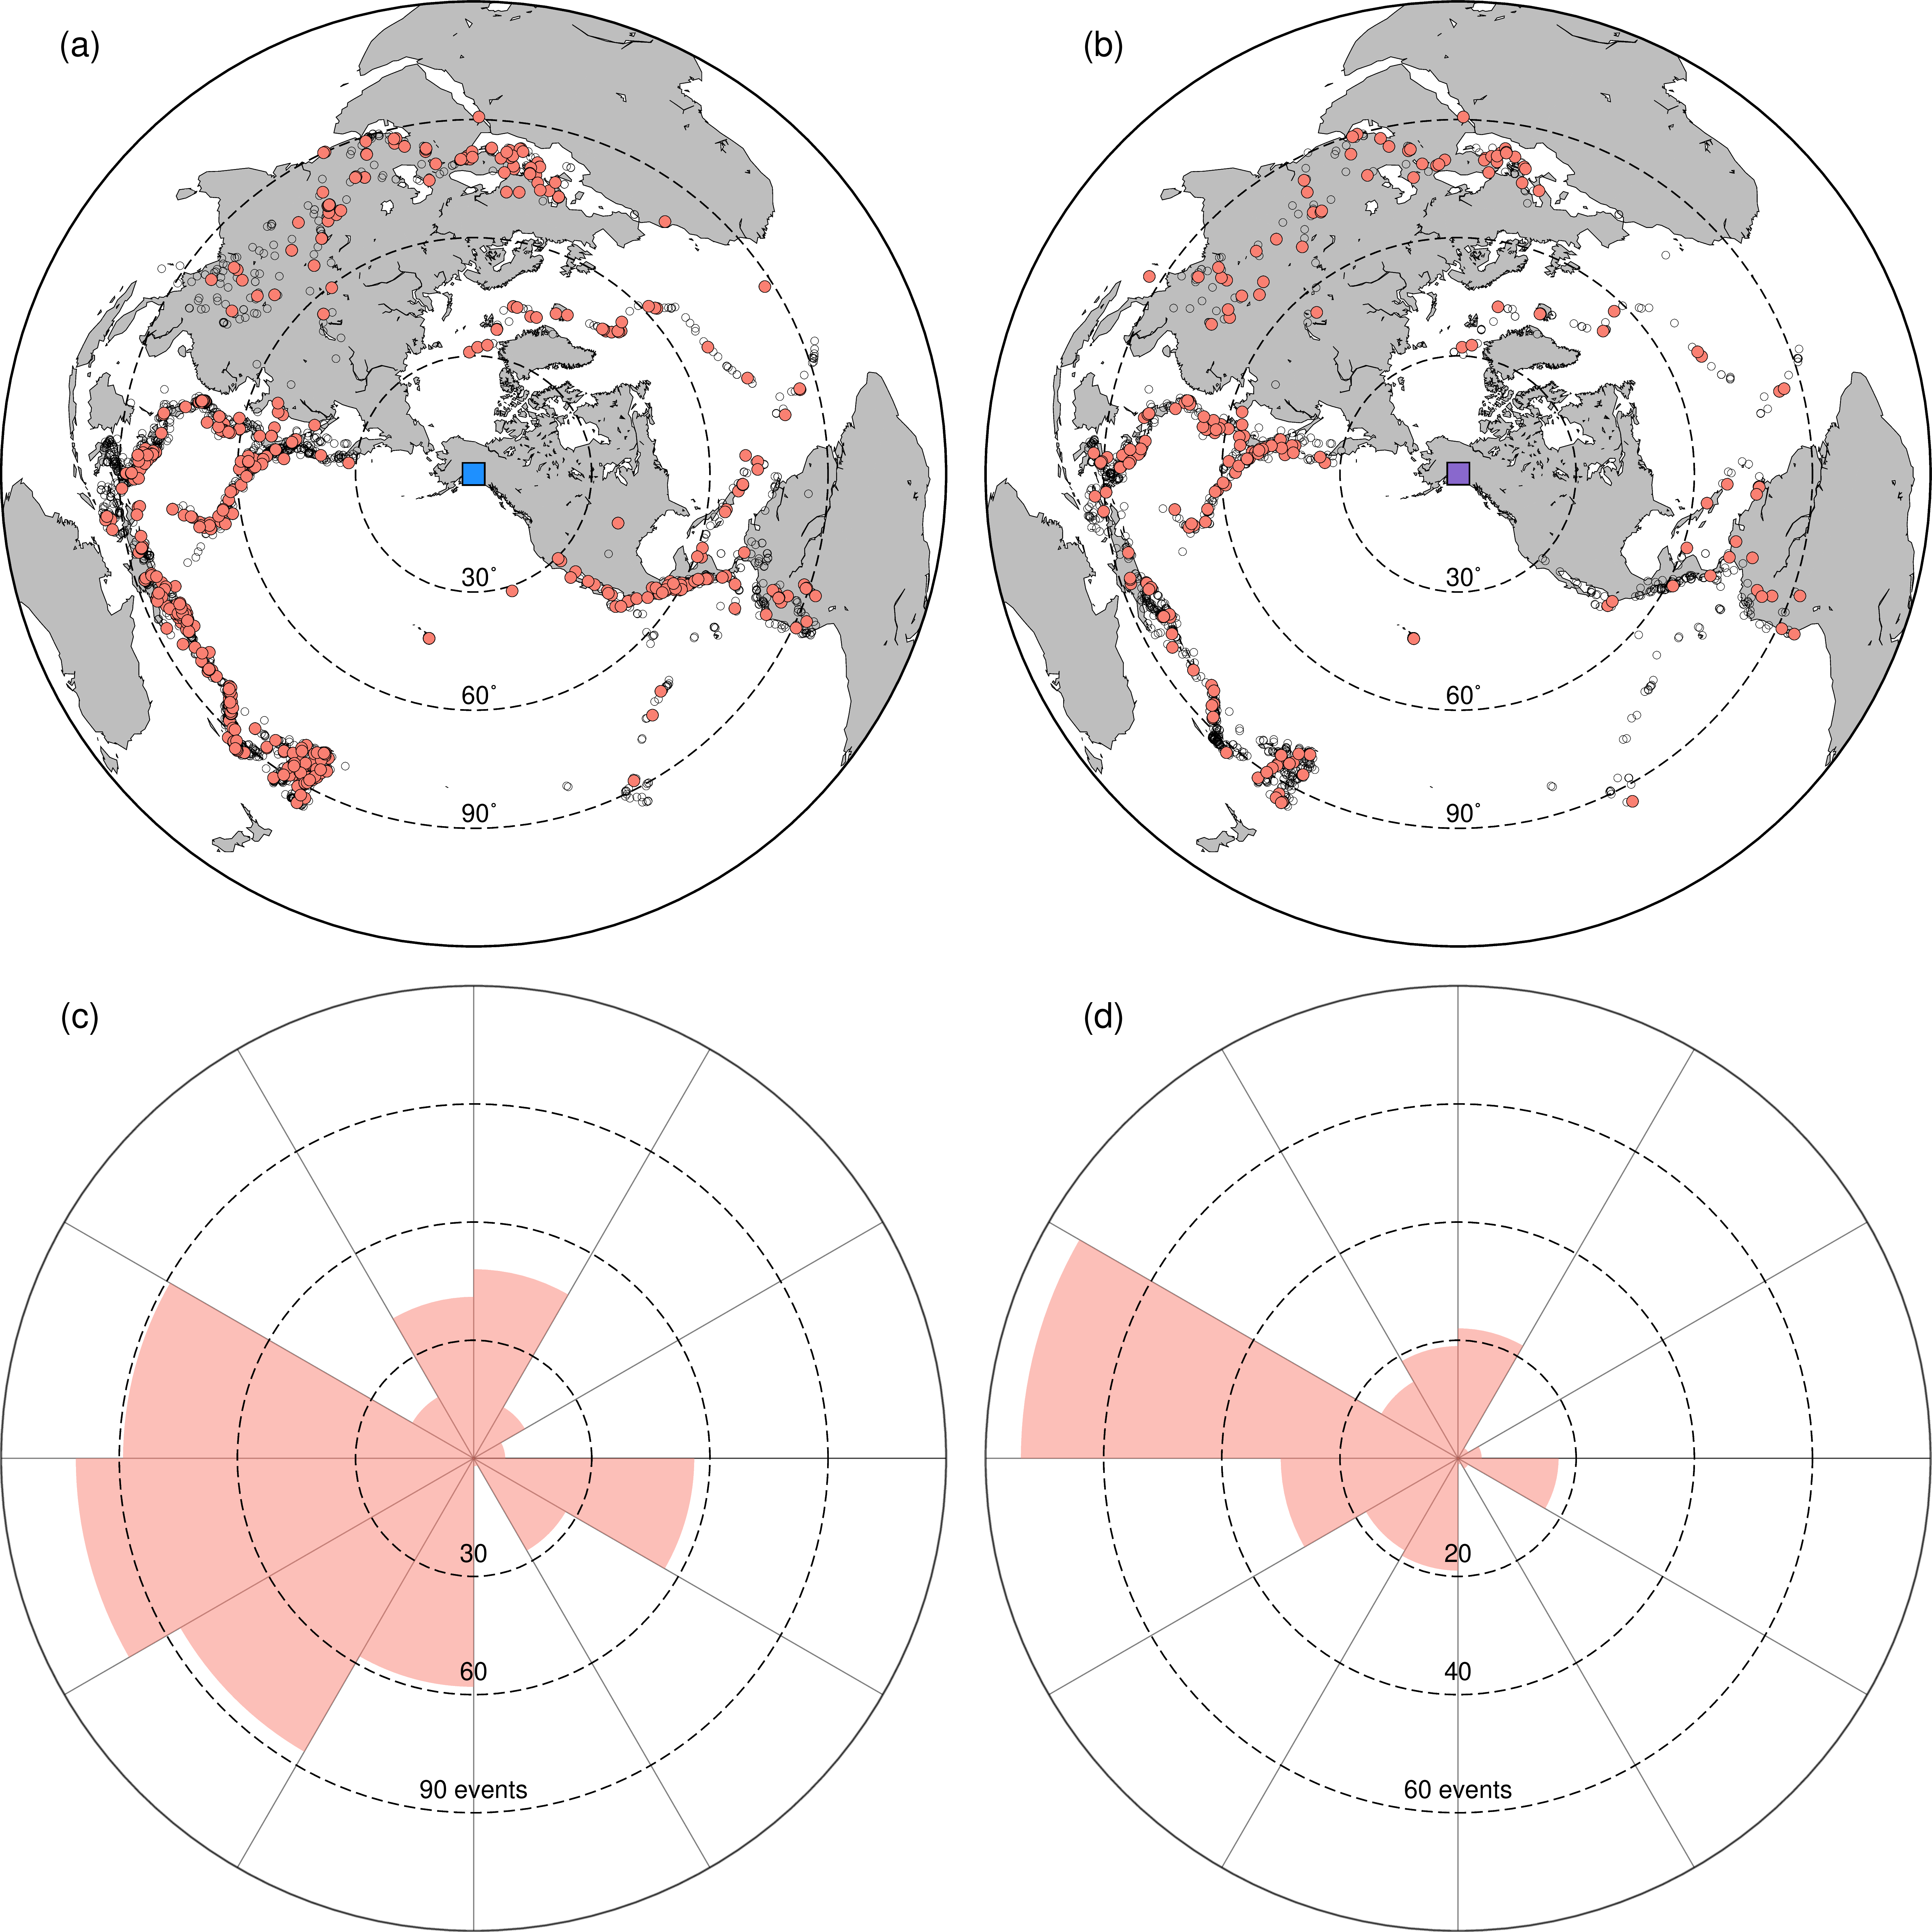
Figure S1. Earthquake distribution map that includes seismic events used for receiver function analysis at stations AV.WACK (a, c) and AV.WAZA (b, d). (a, b) The blue and purple squares mark the location of the two staions. Circles represent earthquake epicenters, with red circles highlighting events selected for further analysis in Figures S3–S5. Three dashed black circles denote 30°, 60°, and 90° epicentral distances, respectively. (c, d) histograms showing the number of receiver functions by backazimuth for each station, in 30° intervals.
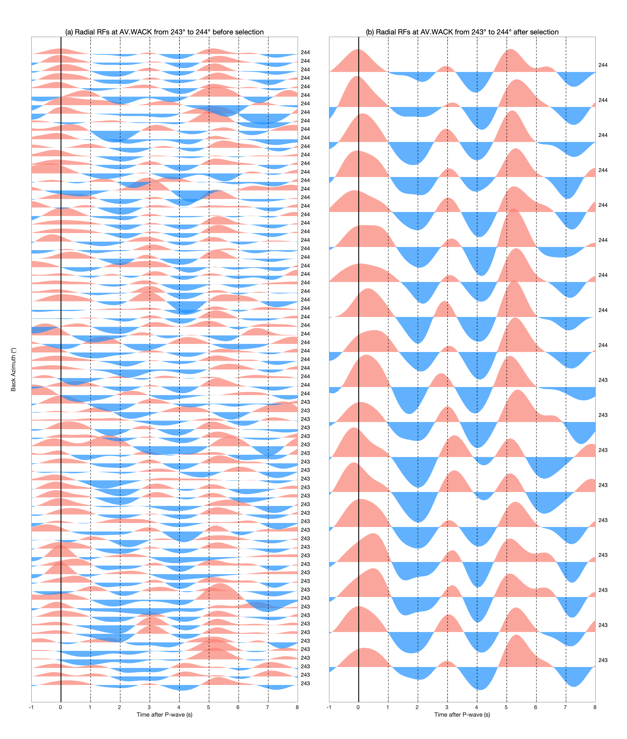Figure S2. Examples of radial receiver functions at station AV.WACK from 243°–244° to show our quality control.
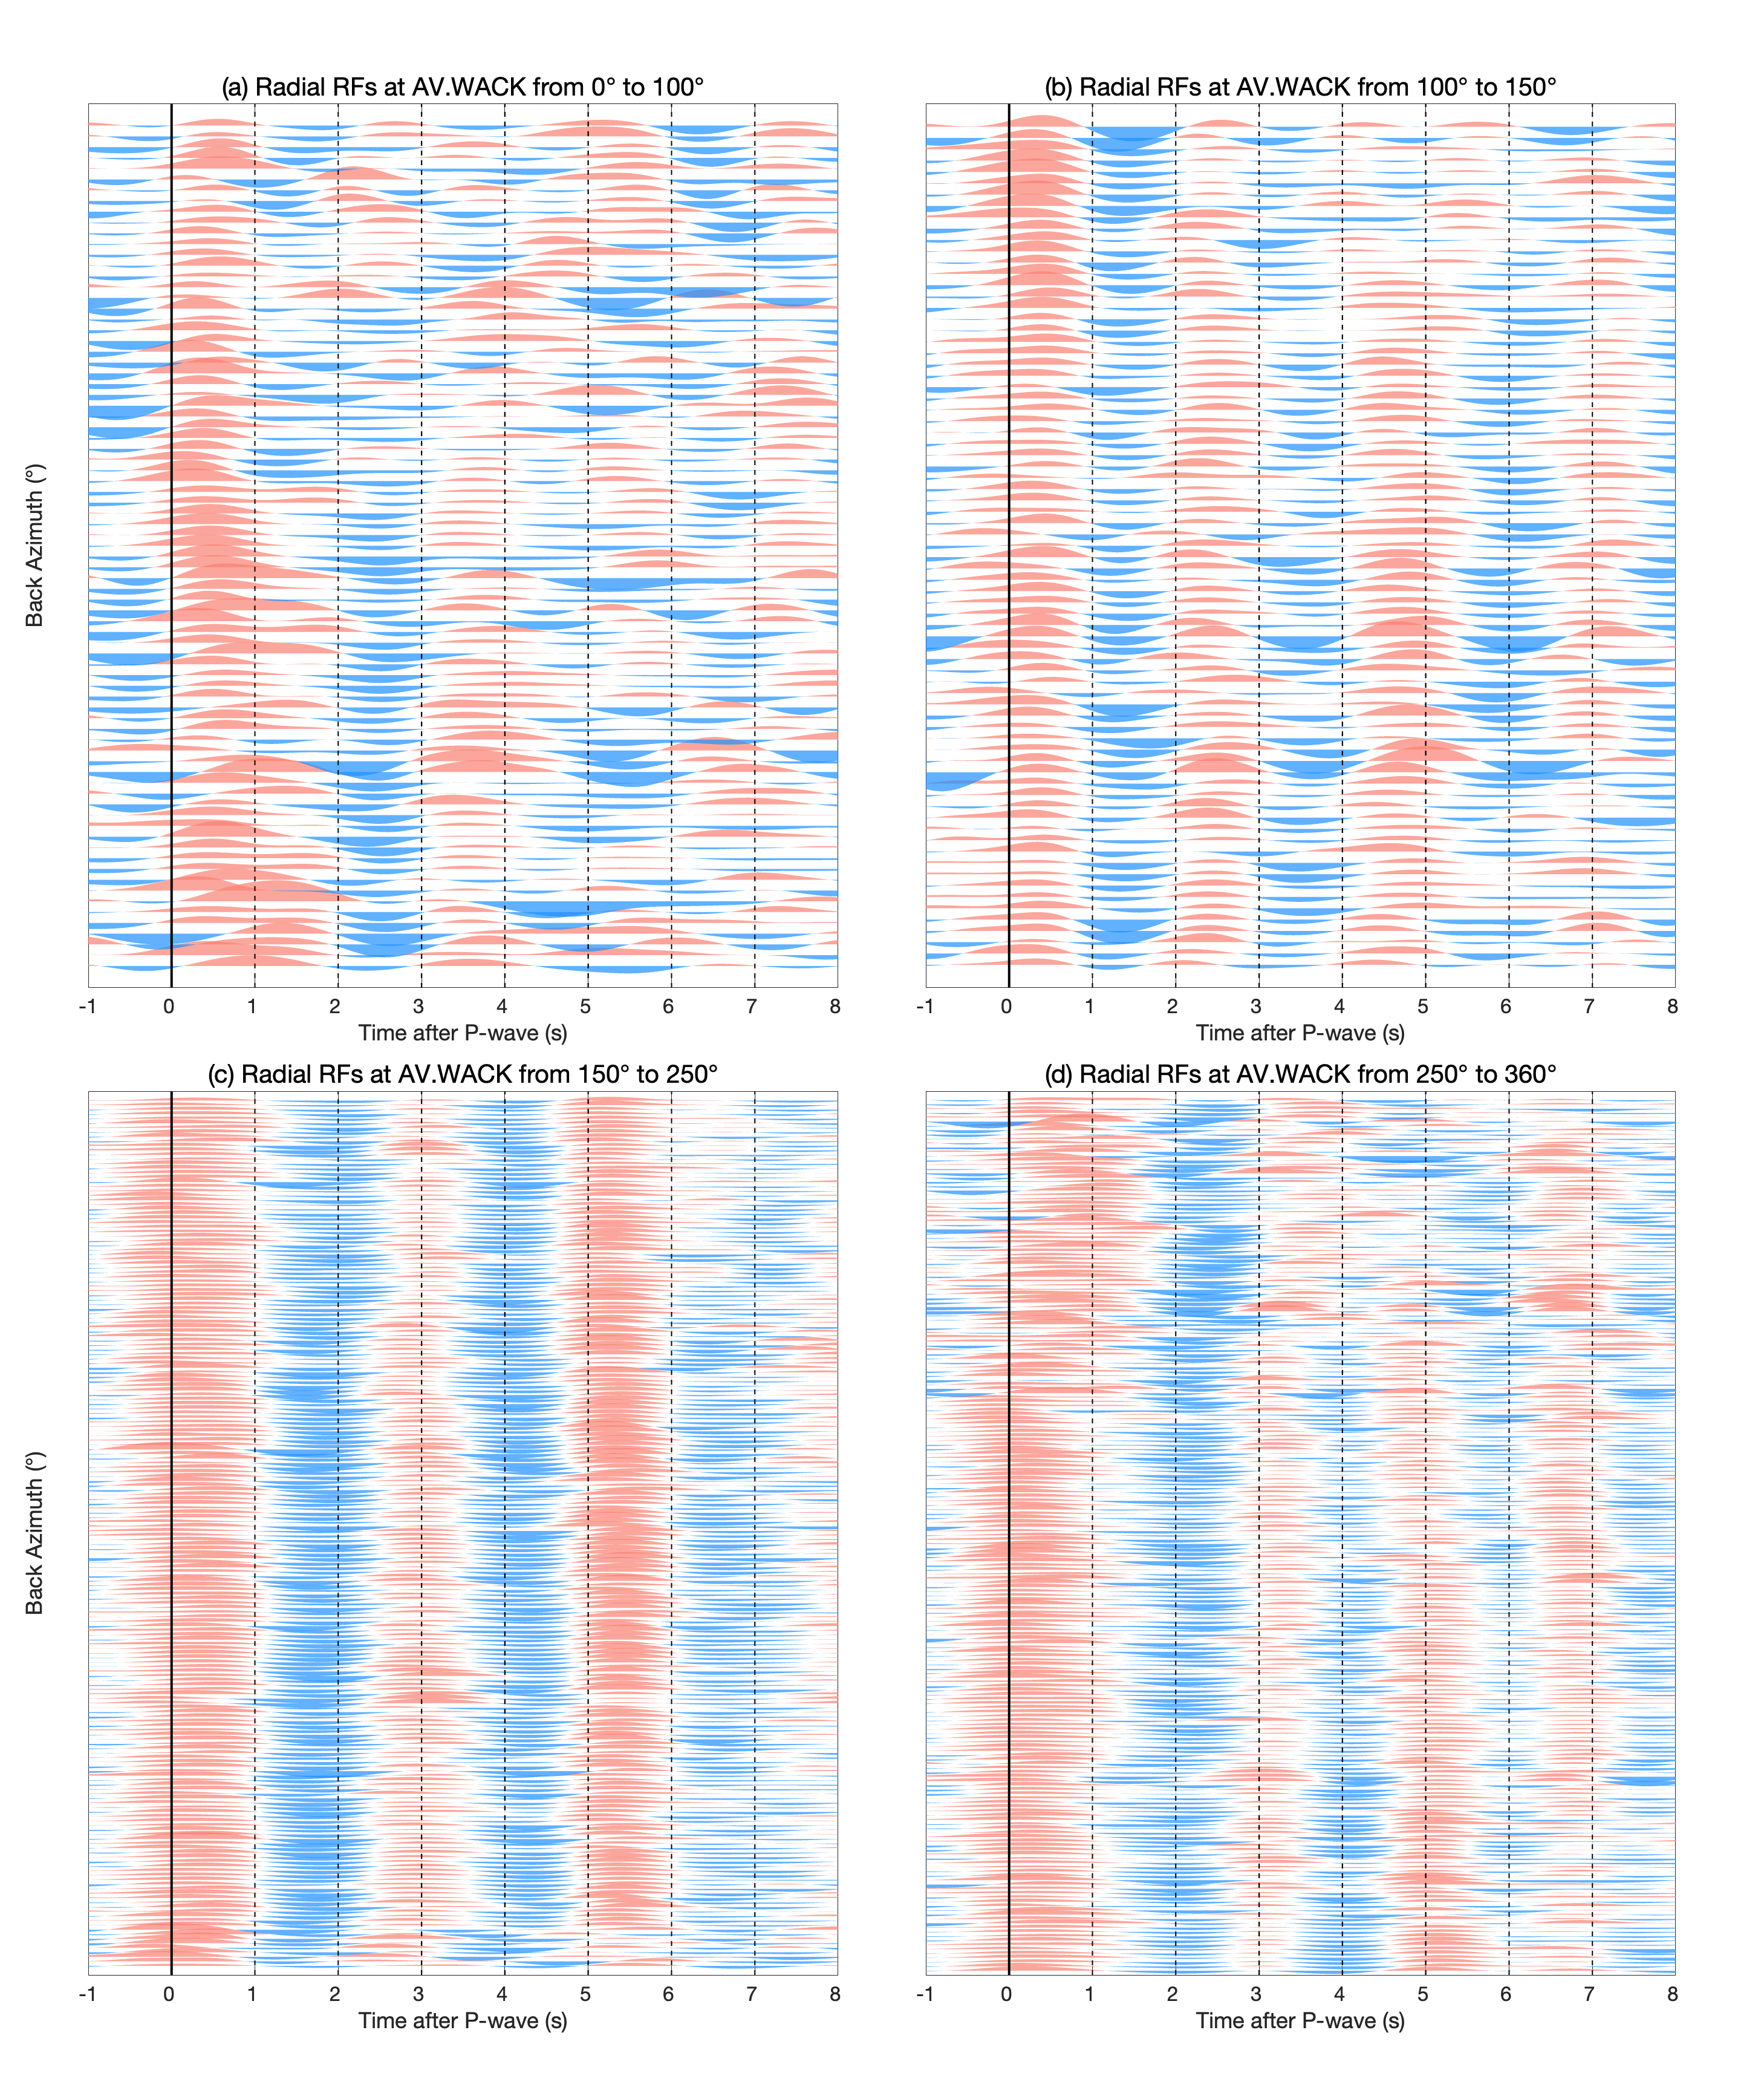
Figure S3. Radial receiver functions for each selected event at station AV.WACK from 0°–100° (a), 100°–150° (b), 150°–250° (c), and 250°–360° (d).
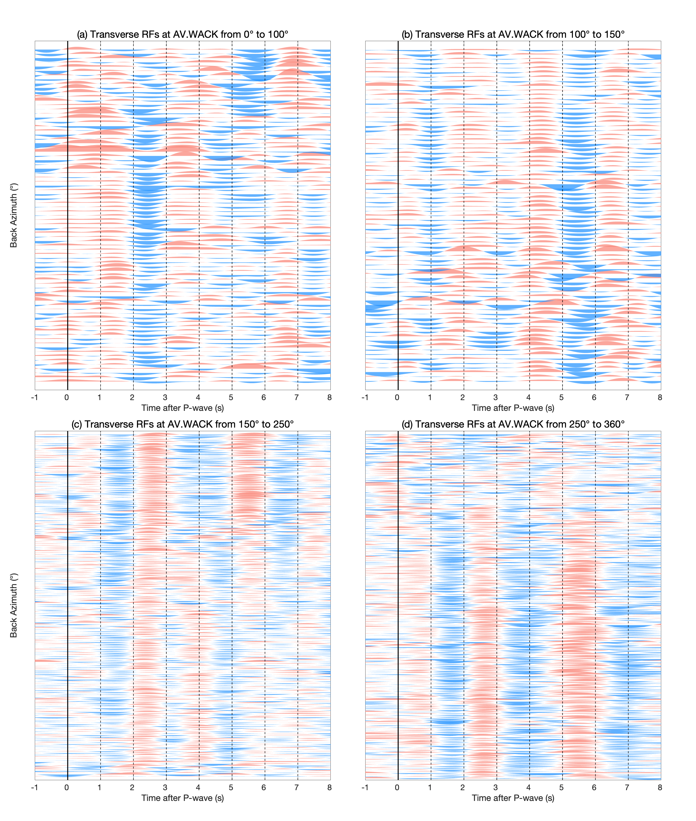
Figure S4. Same as Figure S3, but for transverse receiver functions.
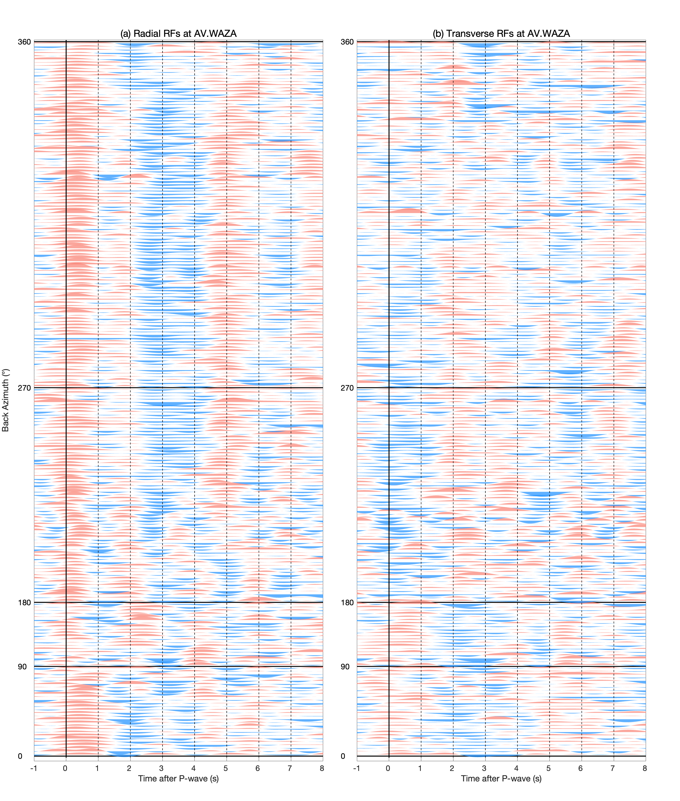
Figure S5. Radial (a) and transverse (b) receiver functions for each selected event at station AV.WAZA. Back azimuths are indicated on the left of each panel.
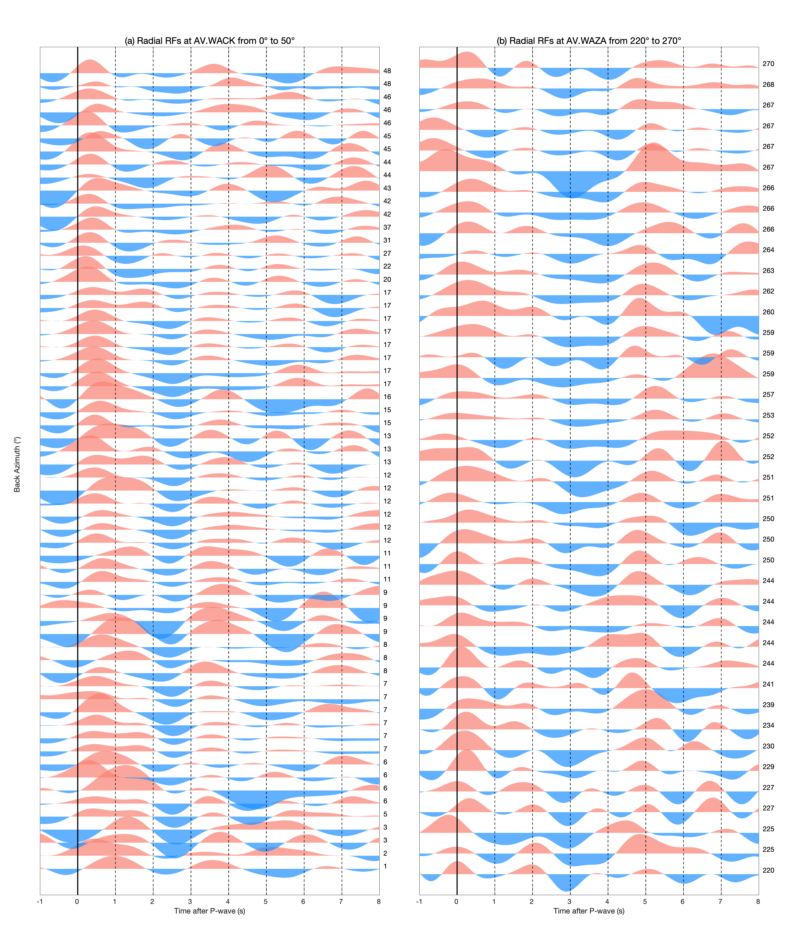
Figure S6. Radial receiver functions at overlapping piercing points (Figure 1) for the two stations. Back azimuths are indicated on the right of each panel.
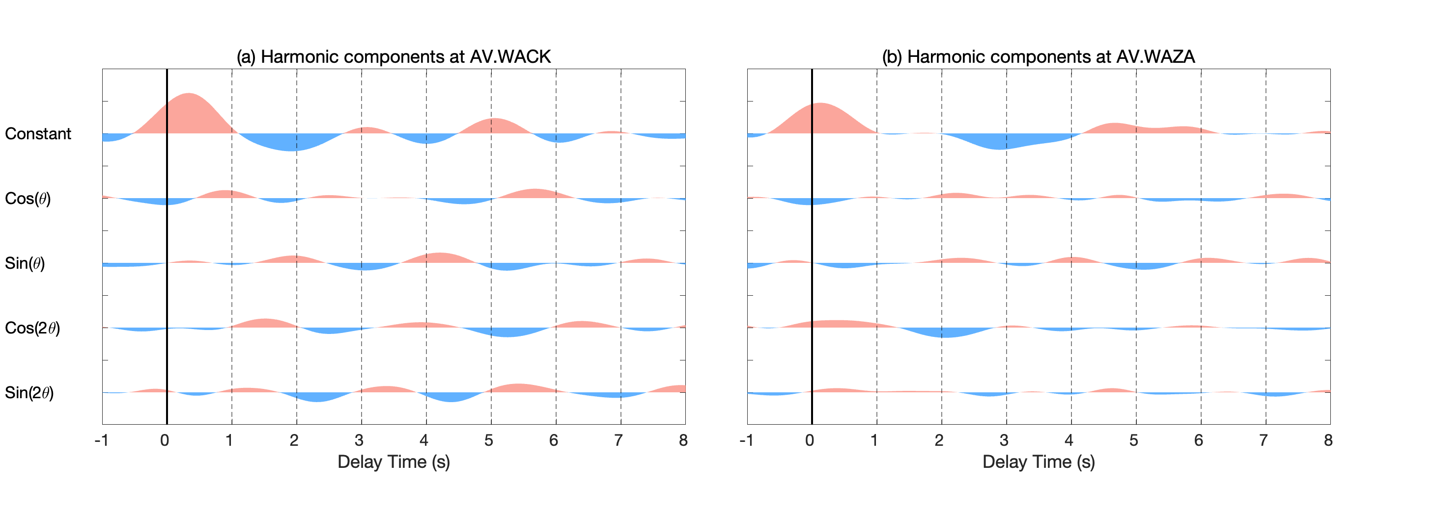
Figure S7. Harmonic terms for receiver functions of stations AV.WACK (a) and AV.WAZA (b).
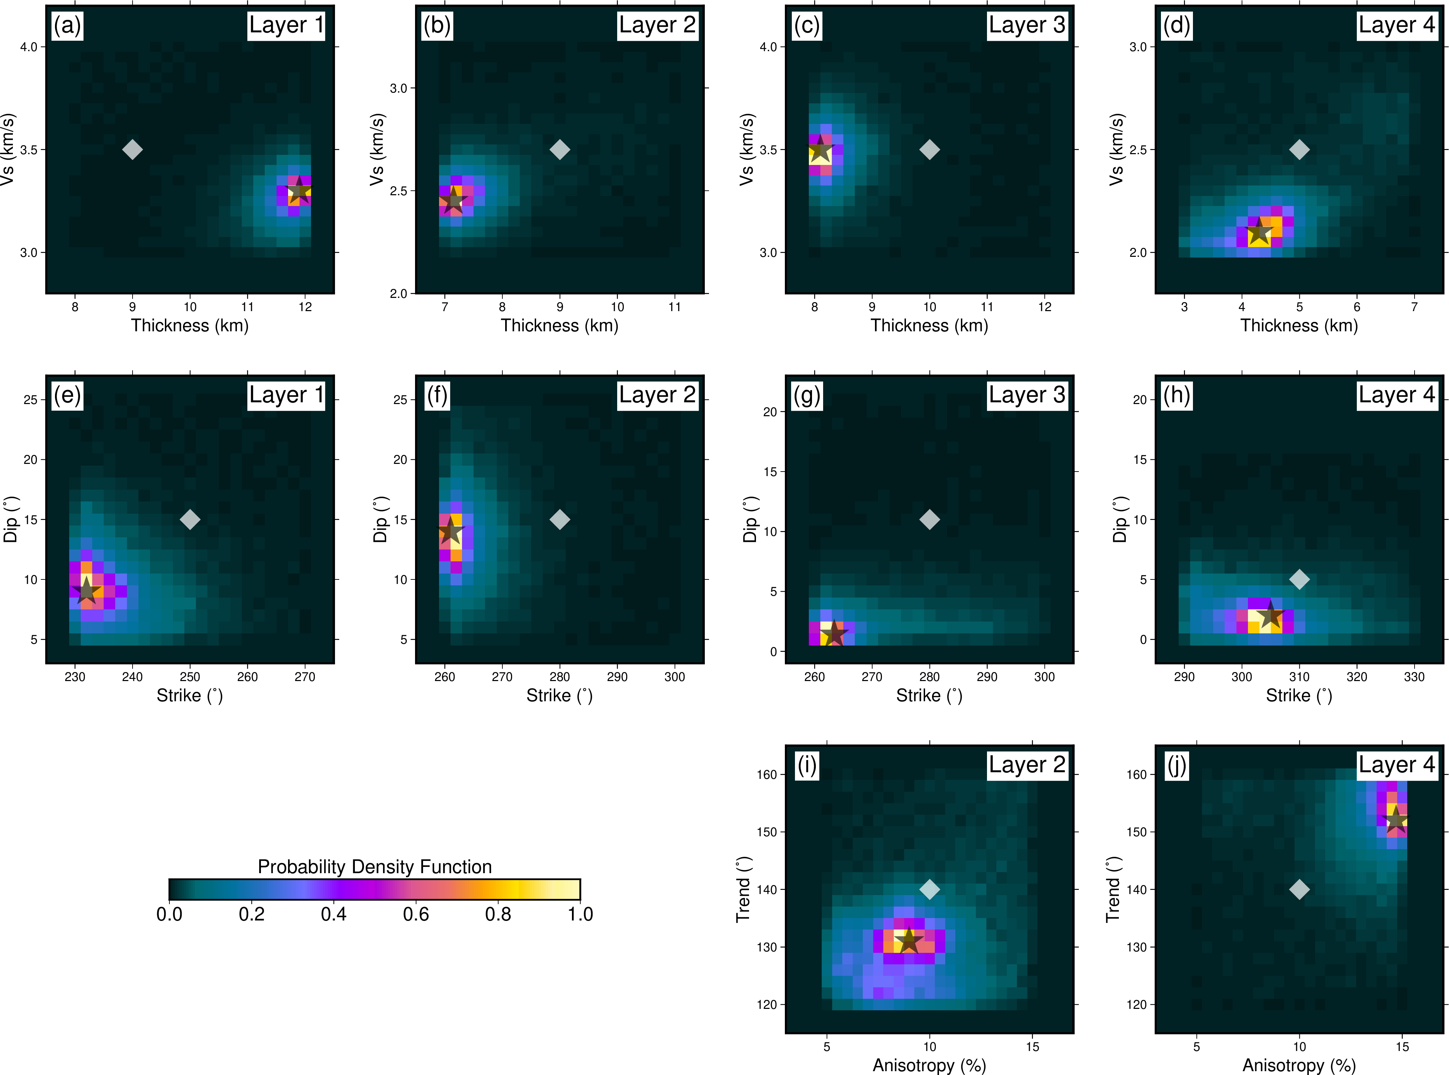
Figure S8. Normalized posterior probability density functions for model variables at station AV.WACK. (a–d) The relations between Vs and thickness of each layer. (e–h) The relations between dip and strike of the bottom of the layer. (i, j) The relations between P-wave anisotropy strength and trend of fast axis. The corresponding layer number is shown in the upper right corner of each panel.
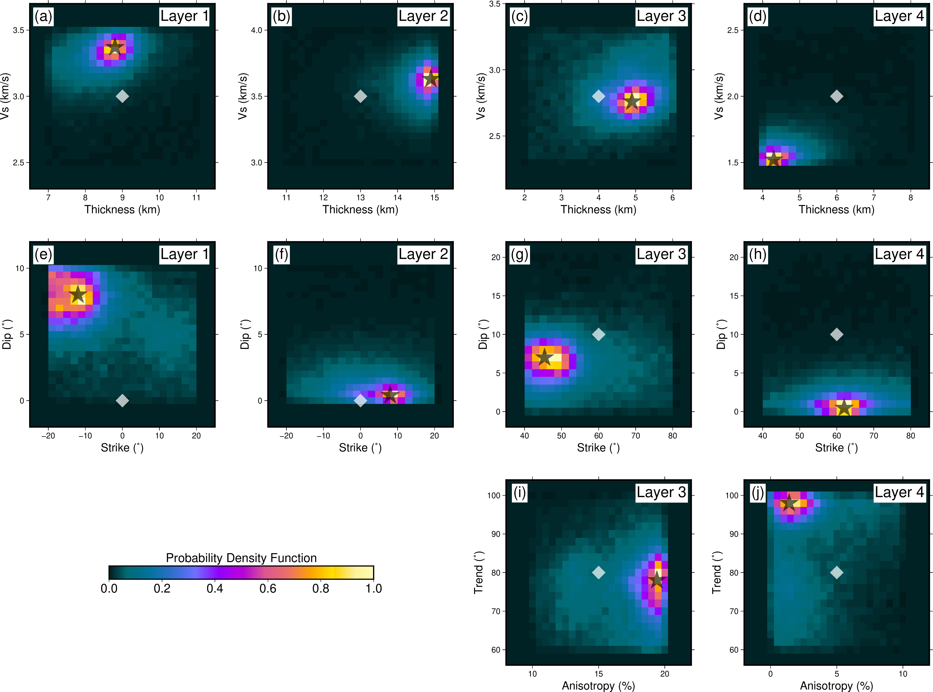
Figure S9. Same as Figure S8, but for station AV.WAZA.
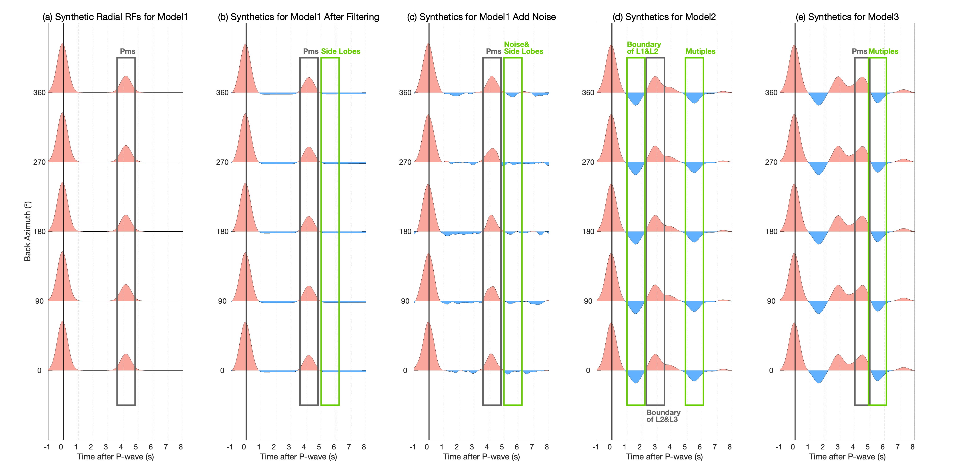
Figure S10. Modeling results of synthetic radial receiver functions for three models. See model configuration in Table S4. (a) Model 1. (b) Same as (a) but with a 0.05–1.5 Hz band-pass filter. (c) Same as (b) but with random noise added according to signal-noise ratio. (d) Model 2. (e) Model 3.
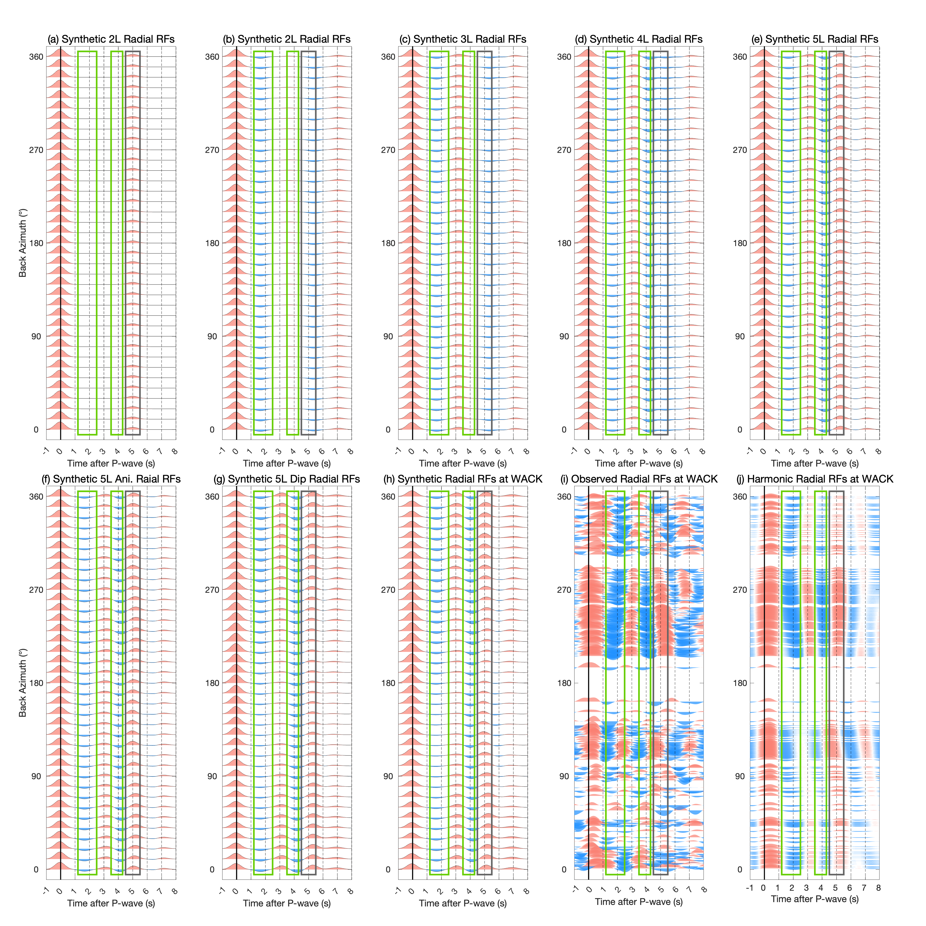
Figure S11. Forward modeling results of radial receiver functions for WACK. See model configuration in Table S2. (a) Two-layer model with a 40 km crust (crust Vs = 3.5 km/s, mantle Vs = 4.5 km/s, Vp/Vs = 1.75). (b) Top two layers of the inverted WACK model without anisotropy or dipping. (c) Top three layers without anisotropy or dipping. (d) Four layers without anisotropy or dipping. (e) Five layers without anisotropy or dipping. (f) Five layers with anisotropy. (g) Five layers with dipping. (h) Final model with anisotropy and dipping. (i) Observed radial receiver functions. (j) Harmonic-analysis-reconstructed receiver functions. Green and gray boxes are same as those in Figures 2a-2d.
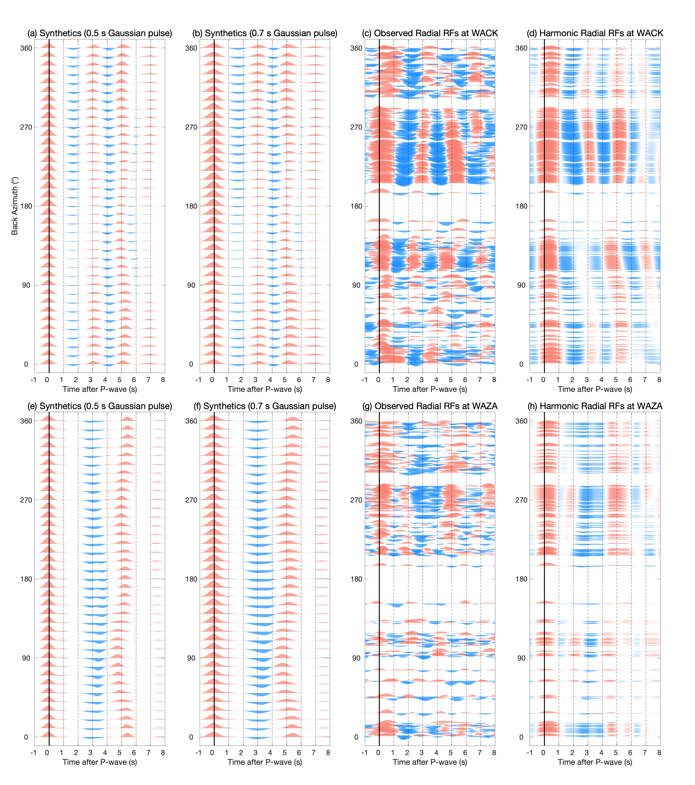
Figure S12. Forward modeling results of radial receiver functions for WACK (upper panel) and WAZA (lower panel). See model configuration in Table S2. (a) and (e) Synthetic radial receiver functions with a 0.5-s Gaussian pulse. (b) and (f) Synthetic radial receiver functions with a 0.7-s Gaussian pulse. (c) and (g) Observed radial receiver functions for WACK and WAZA, respectively. (d) and (h) Corresponding harmonic-analysis-reconstructed receiver functions. Comparison of the frequency content between the synthetic and observed RFs shows that a 0.7-s Gaussian pulse width yields the best match to the observations, and we therefore adopt this value use for the study.

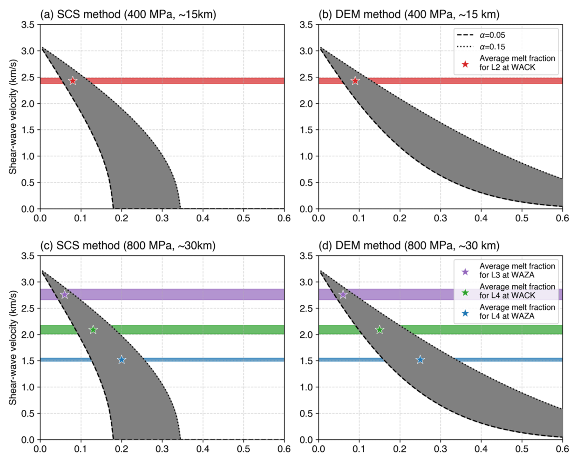
Figure S13. Melt fraction curves at pressures of 400 MPa (a, b; ~15 km depth) and 800 MPa (c, d; ~30 km depth). (a, c) Relationship between melt fraction and shear-wave velocity calculated using the Self-Consistent Scheme (SCS) method (e.g., Berryman, 1980; Paulatto et al., 2022). (b, d) Relationship between melt fraction and shear-wave velocity derived using the Differential Effective Medium (DEM) method (e.g., Avellaneda, 1987; Norris, 1985; Paulatto et al., 2022). The gray shaded area denotes the range of aspect ratios proposed by Takei (2002). Red and green stars indicate the average melt fractions for low-velocity anomalies in Layers 2 and 4 beneath station AV.WACK, respectively, using the aspect ratio of 0.05–0.15 suggested by Takei (2002). Corresponding red and green shaded areas show the shear-wave velocity anomaly ranges for Layers 2 and 4 beneath AV.WACK. Purple and Blue stars represent the average melt fractions for the low-velocity anomalies in Layers 3 and 4 beneath AV.WAZA, respectively. Purple and blue shaded areas represent their shear-wave velocity anomaly ranges.
Table S1. Initial models of stations AV.WACK and AV.WAZA. H, ρ, P-ani., S-ani., trend, plg., strike, and dip represent thickness, density, strength of P-wave anisotropy, strength of S-wave anisotropy, trend of fast axis, plunge of fast axis, strike of interface, dip of interface, respectively.

Station | Layer | H (km) | ρ (g/cm³) | Vp (km/s) | Vs  (km/s) | P-Ani. (%) | S-Ani. (%) | Trend (°) | Plg. (°) | Strike (°) | Dip (°)
AV.  WACK | Layer 1 | 10 | 2.6 | 6.125 | 3.5 | 0 | 0 | 0 | 0 | 0 | 0
AV.  WACK | Layer 2 | 9 | 2.7 | 4.86 | 2.7 | 10 | 5 | 140 | 0 | 250 | 15
AV.  WACK | Layer 3 | 10 | 2.7 | 6.125 | 3.5 | 0 | 0 | 0 | 0 | 280 | 15
AV.  WACK | Layer 4 | 5 | 2.8 | 4.5 | 2.5 | 10 | 5 | 140 | 0 | 280 | 11
AV.  WACK | Mantle | - | 3.3 | 7.875 | 4.5 | 0 | 0 | 0 | 0 | 310 | 5
AV.  WAZA | Layer 1 | 9 | 2.6 | 5.25 | 3 | 0 | 0 | 0 | 0 | 0 | 0
AV.  WAZA | Layer 2 | 13 | 2.7 | 6.475 | 3.7 | 0 | 0 | 0 | 0 | 0 | 0
AV.  WAZA | Layer 3 | 4 | 2.7 | 5.04 | 2.8 | 15 | 15 | 80 | 0 | 0 | 0
AV.  WAZA | Layer 4 | 6 | 2.8 | 3.7 | 2 | 5 | 5 | 80 | 0 | 60 | 5
AV.  WAZA | Mantle | - | 3.3 | 7.875 | 4.5 | 0 | 0 | 0 | 0 | 60 | 5

Table S2. Final seismic models for stations AV.WACK and AV.WAZA obtained from neighborhood algorithm inversion. Strike and dip represent the layer above. Parameters with associated uncertainties represent those that are searched during the inversion.

Station | Layer | H (km) | ρ (g/cm³) | Vp (km/s) | Vs  (km/s) | P-Ani. (%) | S-Ani. (%) | Trend (°) | Plg. (°) | Strike (°) | Dip (°)
AV.  WACK | Layer 1 | 11.9±0.1 | 2.6 | 6.125 | 3.30±0.04 | 0 | 0 | 0 | 0 | 0 | 0
AV.  WACK | Layer 2 | 7.1±  0.2 | 2.7 | 4.86 | 2.43±0.05 | 9±2 | 5 | 131±4 | 0 | 232±4 | 9±2
AV.  WACK | Layer 3 | 8.1±  0.1 | 2.7 | 6.125 | 3.47±0.07 | 0 | 0 | 0 | 0 | 261±1 | 14±2
AV.  WACK | Layer 4 | 4.3±  0.4 | 2.8 | 4.5 | 2.09±0.08 | 15±1 | 5 | 152±3 | 0 | 263±3 | 1±1
AV.  WACK | Mantle | - | 3.3 | 7.875 | 4.5 | 0 | 0 | 0 | 0 | 305±6 | 2±1
AV.  WAZA | Layer 1 | 8.8±  0.3 | 2.6 | 5.25 | 3.37±0.06 | 0 | 0 | 0 | 0 | 0 | 0
AV.  WAZA | Layer 2 | 14.9±0.2 | 2.7 | 6.475 | 3.63±0.06 | 0 | 0 | 0 | 0 | 348±7 | 8±2
AV.  WAZA | Layer 3 | 4.9±  0.5 | 2.7 | 5.04 | 2.76±0.10 | 19±1 | 15 | 79±7 | 0 | 8±7 | 0±1
AV.  WAZA | Layer 4 | 4.3±  0.2 | 2.8 | 3.7 | 1.52±0.03 | 1±1 | 5 | 97±4 | 0 | 45±5 | 7±2
AV.  WAZA | Mantle | - | 3.3 | 7.875 | 4.5 | 0 | 0 | 0 | 0 | 62±6 | 0±0

Table S3. Comparison of this study with a few previous studies in terms of the Moho depth beneath stations AV.WACK and AV.WAZA.

 | Seismic wave | Methods | WACK/WAZA included | Reference model | Moho estimate
This study | Ps converted body waves | Neighborhood algorithm inversion | Yes | Combination of harmonic decomposition analysis with Yang & Gao (2020) | WACK: 31.4 km  WAZA: 32.9 km
Liu & Gao (2023) | Ps converted body waves | Common conversion point stacking | Yes | Berg et al. (2020) | WACK: 41.9 km  WAZA: 39.2 km
Gama et al. (2022) | Sp converted body waves | Common conversion point stacking | Yes | Nayak et al. (2020) | WACK: 42.3 km  WAZA: 37.7 km
Zhang et al. (2019) | Ps converted body waves | H-$κ$ stacking | No | - | ~38 km

Table S4. Model parameters of three simplified models.

Model | Layer | H (km) | ρ (g/cm3) | Vp (km/s) | Vs (km/s)
Model 1 | Layer 1 | 32 | 2.8 | 6.052 | 3.4
Model 1 | Mantle | - | 3.3 | 7.875 | 4.5
Model 2 | Layer 1 | 12 | 2.8 | 5.874 | 3.3
Model 2 | Layer 2 | 7 | 2.9 | 4.272 | 2.4
Model 2 | Layer 3 | - | 2.9 | 6.230 | 3.5
Model 3 | Layer 1 | 12 | 2.8 | 5.874 | 3.3
Model 3 | Layer 2 | 7 | 2.9 | 4.272 | 2.4
Model 3 | Layer 3 | 13 | 2.9 | 6.230 | 3.5
Model 3 | Mantle | - | 3.3 | 7.875 | 4.5

