Supplementary material

Pan-alpine summer temperatures since 742 CE

Jan Esper, Frederick Reinig, Max Torbenson, Edurne Martinez del Castillo, Marcel Kunz, Alberto Arzac, Marco Carrer, Feng Chen, Alper K. Kadioglu, Alexander V. Kirdyanov, Ernesto Tejedor, Mirek Trnka, Ulf Büntgen

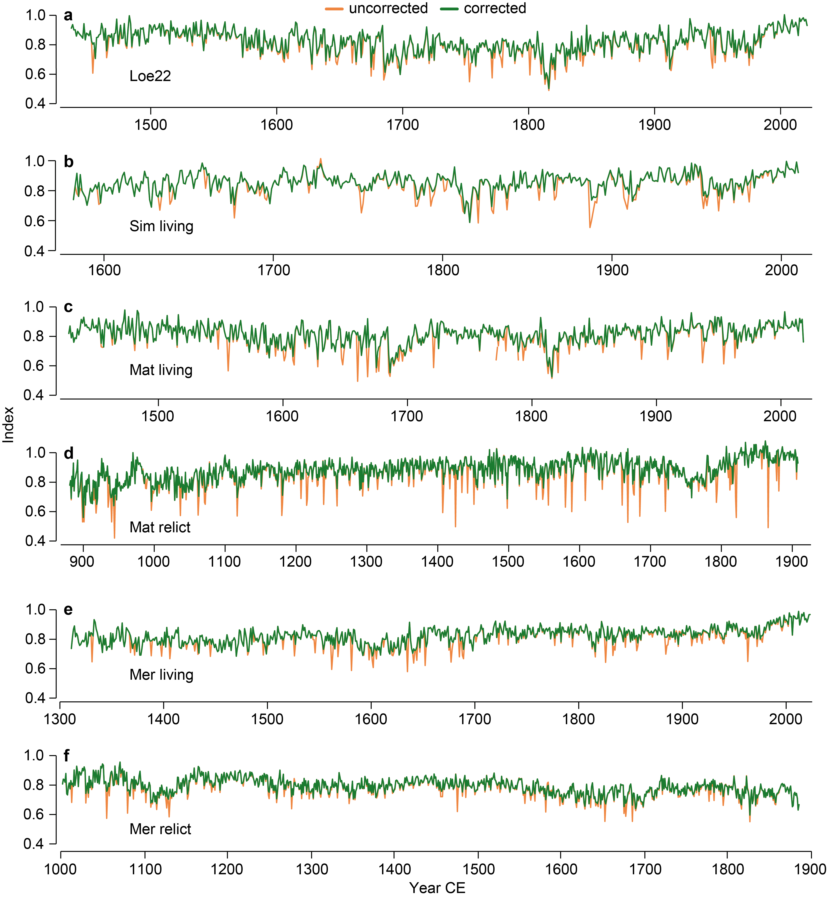
Fig. S1 Larch budmoth (LBM) infestation correction. Raw MXD chronologies before (orange) and after (green) LBM signal removal of the a, Lötschen valley update (Loe22), b, Simplon valley living-tree (Sim living), c, Matter valley living-tree (Mat living), d, Matter valley relict-tree (Mat relict), e, Merveille valley living-tree (Mer living), and f, Merveille valley relict-tree data (Mer relict).
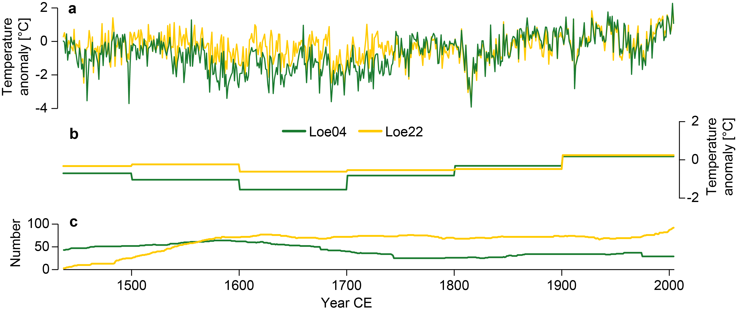
Fig. S2 Comparison of old and new Lötschen valley MXD chronologies. a, RCS-detrended Loe04 chronology as used in Bün06 (green) and update Loe22 chronology (yellow), both scaled against June-September temperature anomalies (with respect to 1951-1980 CE) since 1880 CE and shown over their common period from 1437-2004 CE. b, Same as in a, but after calculating centennial means (1437-1500 CE for the earliest and 1901-2004 CE for the most recent interval). c, Chronology replication curves.

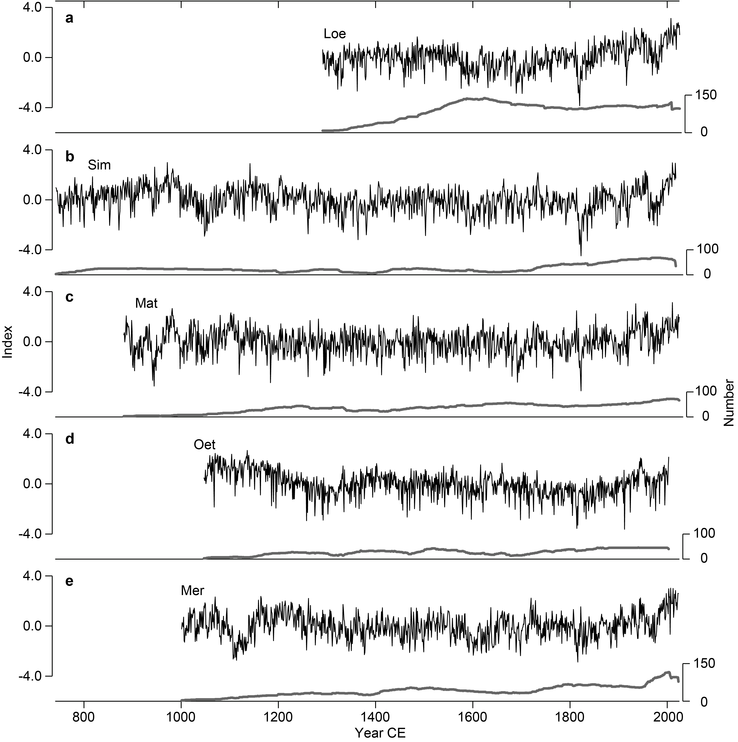
Fig. S3 Detrended and variance stabilized MXD chronologies of the Lötschen (a), Simplon (b), Matter (c), Ötz (d), and Merveille valleys (e). Bottom panels show replication curves in grey.

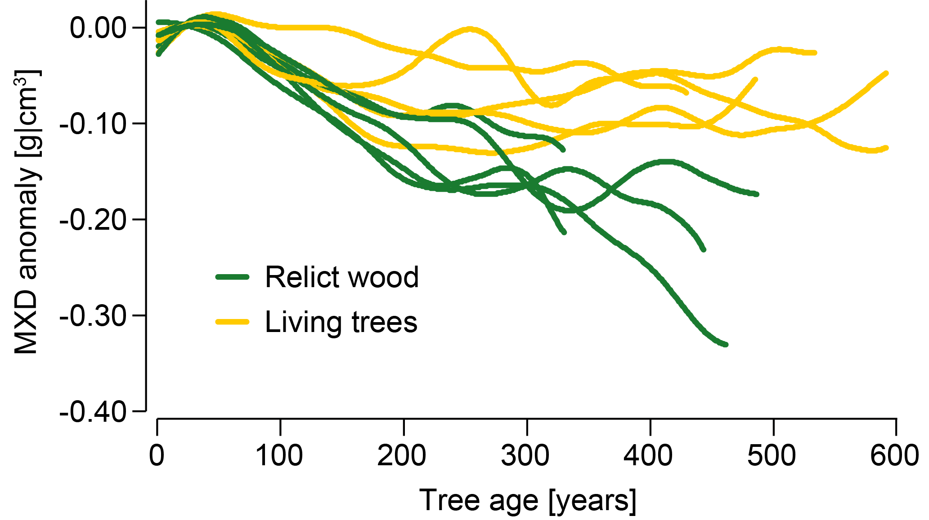
Fig. S4 Age-aligned regional curves of living-tree (yellow) and relict larch samples (green) from the Lötschen, Simplon, Matter, and Merveille valleys.

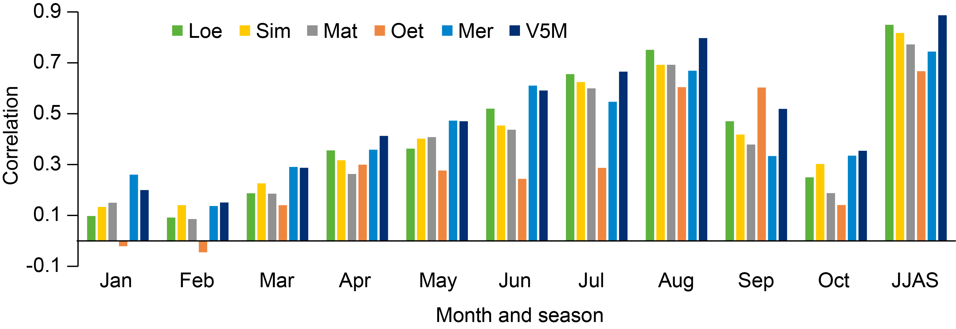
Fig. S5 Valley chronology and V5M correlations against monthly and seasonal temperatures since 1880 CE. Note the varying chronology end dates (Table 1).

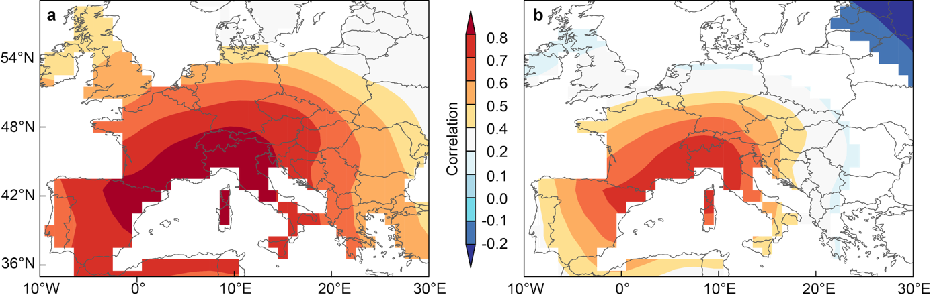
Fig. S6 PAN-ALP spatial temperature signal. a, Correlation patterns of the PAN-ALP reconstruction against Berkeley Earth gridded June-September temperatures since 1880 CE. b, Same as in a, but after first-differencing the reconstruction and temperature field.

