Geochemistry, Geophysics, Geosystems
Supporting Information for
Detection and Analysis of Aleutian Arc Seismicity (2022-2023) Using an Autonomous Hydrophone Array

Vaibhav Vijay Ingale¹, Gabrielle Tepp², Robert P Dziak³, Ross Parnell-Turner¹
¹Institute of Geophysics and Planetary Physics, Scripps Institution of Oceanography, University of California San Diego, La Jolla, CA, USA
²Seismological Laboratory, Caltech, Pasadena, CA, USA
³Pacific Marine Environmental Laboratory, National Oceanic and Atmospheric Administration, Newport, OR, USA

Corresponding author: Vaibhav Vijay Ingale (vingale@ucsd.edu)

Contents of File:
Table S1: Location parameters of hydrophones deployed in Bering Sea
Table S2: Summary of individual type of hydroacoustic phases and their match with seismic events near Tanaga Island in 2022-2023
Table S3: Summary of all T- and short-duration hydroacoustic phases and their match with seismic events either along the trench or near Tanaga Island
Figure S1: Alaska Earthquake Center and Alaska Volcano Observatory networks
Figure S2: Example of hydroacoustic locations obtained using non-least square minimization of arrival times
Figure S3: Observed and estimated arrival time differences of matched events from USGS catalog
Figure S4: Time difference between different successive phases of T-phase signals
Figure S5: Time difference between different successive phases of impulsive signals
Figure S6: Spatial distribution of hydroacoustically matched seismic events near Tanaga
Figure S7: Rise time of different hydroacoustic signals
Figure S8: Spatial distribution of seismic events that matched with T-phases along Aleutian Arc
Figure S9: Spatial distribution of seismic events that matched with T-phases near Great Sitkin Island
Figure S10: Spatial distribution of seismic events that matched with short-duration phases along Aleutian Arc
Figure S11: Spatial distribution of seismic events that matched with short-duration phases near Tanaga Island
Figure S12: Events depth obtained from USGS catalog between 1 and 15 March, 2023
Figure S13: Elevation profiles along paths from volcanic centers to hydrophone array

Site | H32 | H38 | H40 | H41
Latitude (°N) | 53.3396 | 53.4038 | 53.3384 | 53.2725
Longitude (°W) | -176.5764 | -176.4708 | -176.3639 | -176.4711
Bottom depth (m) | 3774 | 3776 | 3771 | 3769
Sampling rate (Hz) | 2000 | 2000 | 2000 | 2000
Sensitivity (dB) | -193 | -193 | -193 | -193
Table S1: Location parameters of hydrophones deployed in Bering Sea
Hydroacoustic event type | Hydroacoustic numbers | Matched seismic event numbers
Isolated T-phase | 318 | 56
Composite PST-phase | 75 | -
Composite PT-phase | 187 | -
Paired T-phase | 48 | -
Impulsive I phase | 2110 | 1025
Impulsive II phase | 225 | 102
Doublet phase | 69 | 32
Uncategorized phase | 1554 | 448
Table S2: Summary of individual type of hydroacoustic phases and their match with seismic events near Tanaga Island in 2022-2023
Hydroacoustic event type | Seismic match location | % of matched seismic events | Seismic match depth (km)
All T-phases | Along trench | 9% | 49.7 ± 43.0
All T-phases | Near Tanaga Island | 74% | 3.6 ± 3.2
All T-phases | Near Great Sitkin Island | 7% | 13.5 ± 3.4
All short-duration phases | Along trench | 25% | 16.4 ± 12.6
All short-duration phases | Near Tanaga Island | 41% | 4.0 ± 2.8
All short-duration phases | Near Great Sitkin Island | - | -
Table S3: Summary of all T- and all short-duration hydroacoustic phases and their match with seismic events either along the trench, near Tanaga and Great Sitkin Islands. The higher uncertainties in depth are due to skewed distribution of USGS catalog event depths.

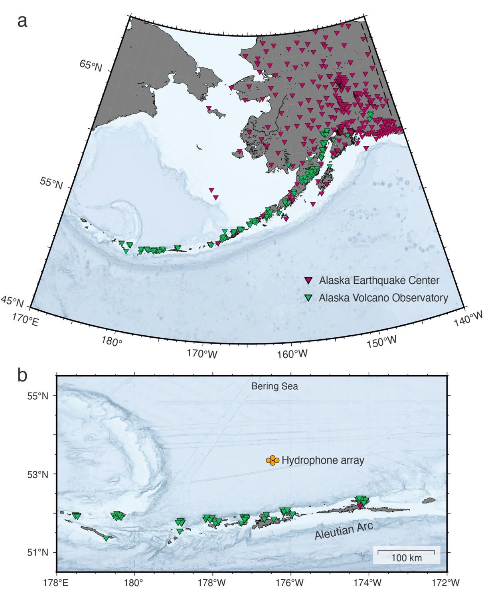

Figure S1: Seismic network maintained by the Alaska Earthquake Center, Univ. of Alaska Fairbanks (1987; pink) and Alaska Volcano Observatory/USGS (1988; green) between 1979-2023 along a) entire Aleutian Arc trench and b) trench region shown in Figure 1. Orange circles are hydrophones used in this study.
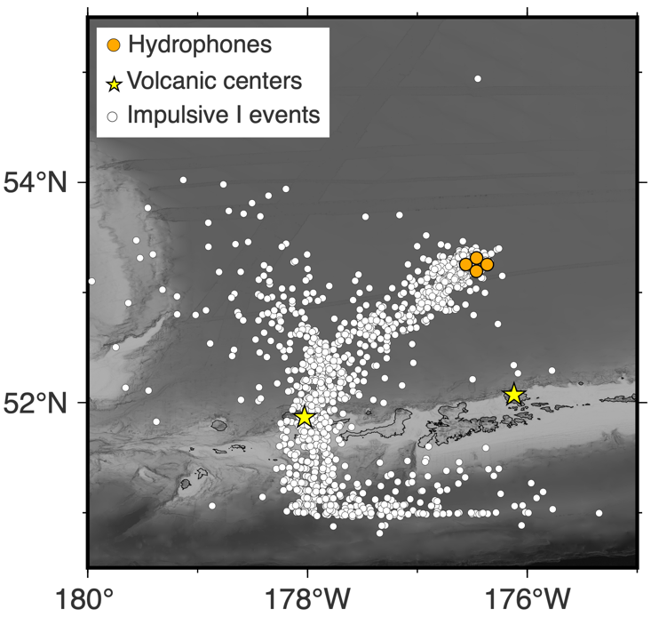
Figure S2: Location of hydroacoustic events (short duration impulsive type) obtained after non-linear least-squares minimization of arrival times.
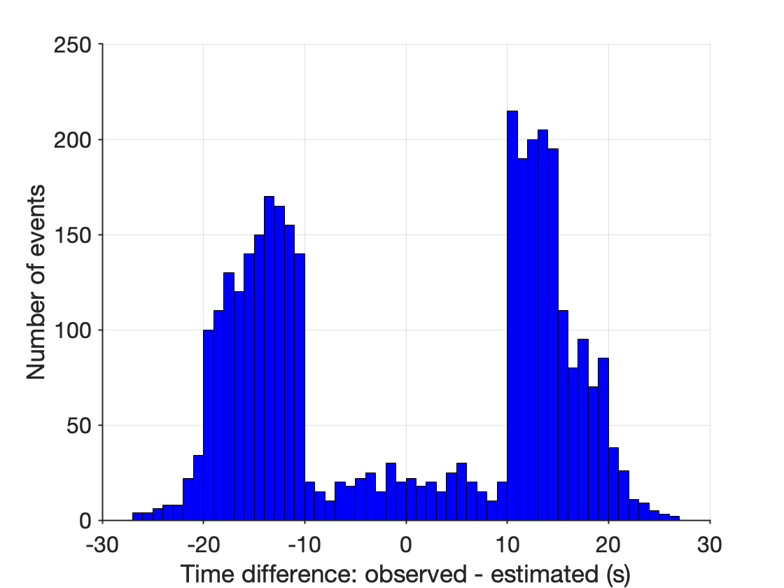
Figure S3: Histogram of observed and estimated arrival time difference at H41 hydrophone of matched events from USGS catalog. The estimated arrival time is calculated using acoustic waves traveling at 1.462 km/s from USGS catalog locations.
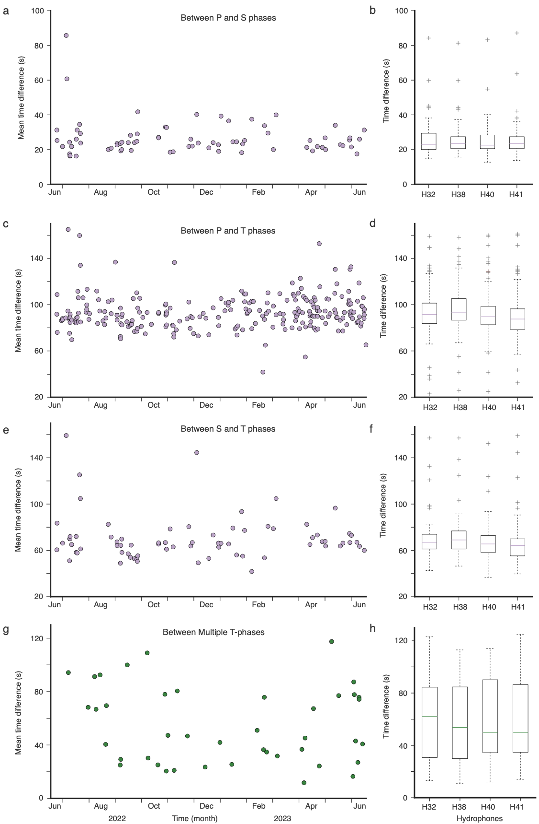
Figure S4: Distribution of mean time difference on four hydrophones between successive phases for different types of signals: a-b) P and S phases, c-d) P and T phases, e-f) S and T phases, and g-h) Paired T-phases plotted by day (left) and as box-error plots (right) for each station.
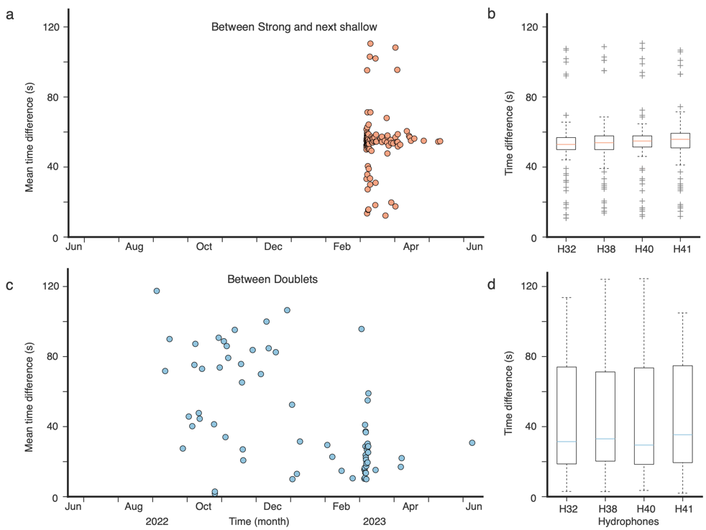
Figure S5: Distribution of mean time difference on four hydrophones between successive phases for different types of signals: a-b) Impulsive II and successive short-duration phase, and c-d) doublet phases plotted by day (left) and as box-error plots (right) at each station.
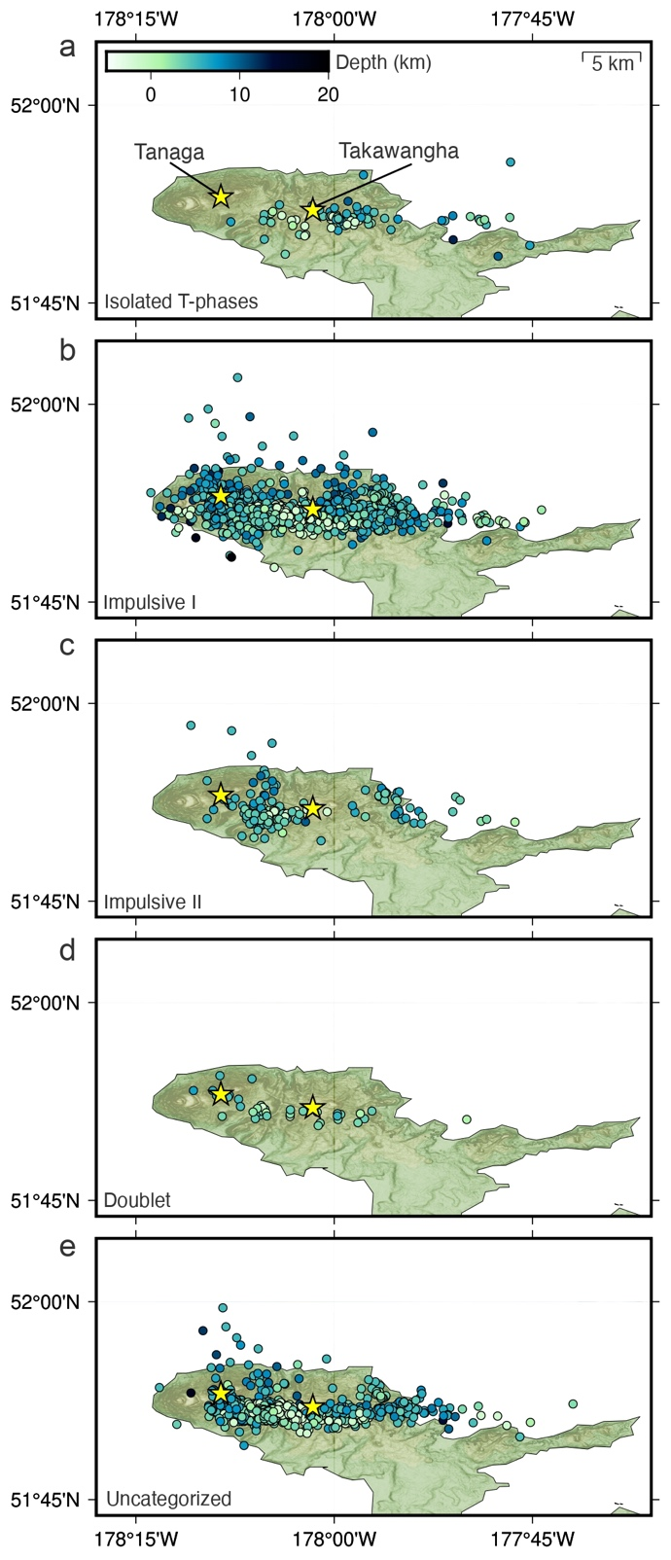
Figure S6: Spatial distribution of seismic events from the USGS catalog near Tanaga Island between 2022-2023 that matched with different types of hydroacoustic phases: a) isolated T-phases, b) impulsive I, c) impulsive II, d) doublet and e) uncategorized phases.
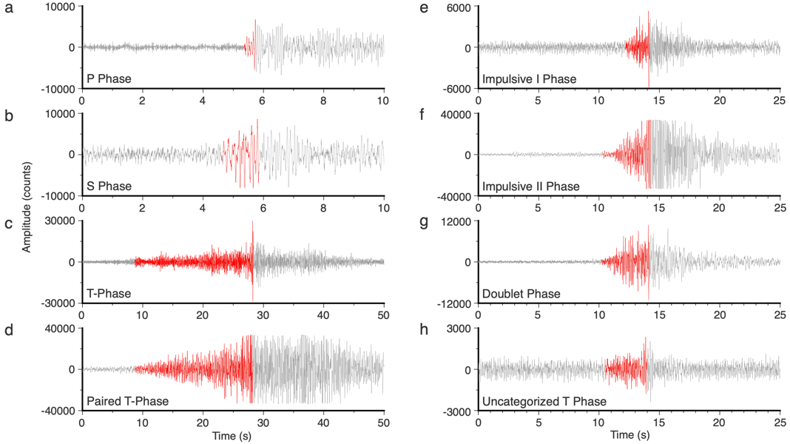

Figure S7: Rise time of a signal measured as time between onset above noise and maximum amplitude is shaded in red for different types of signals: a) P phase, b) S phase, c) T-phase d) first waveform of multiple T-phases, e) impulsive I phase, f) impulsive II phase, g) first waveform of doublet phase, and h) uncategorized phases.
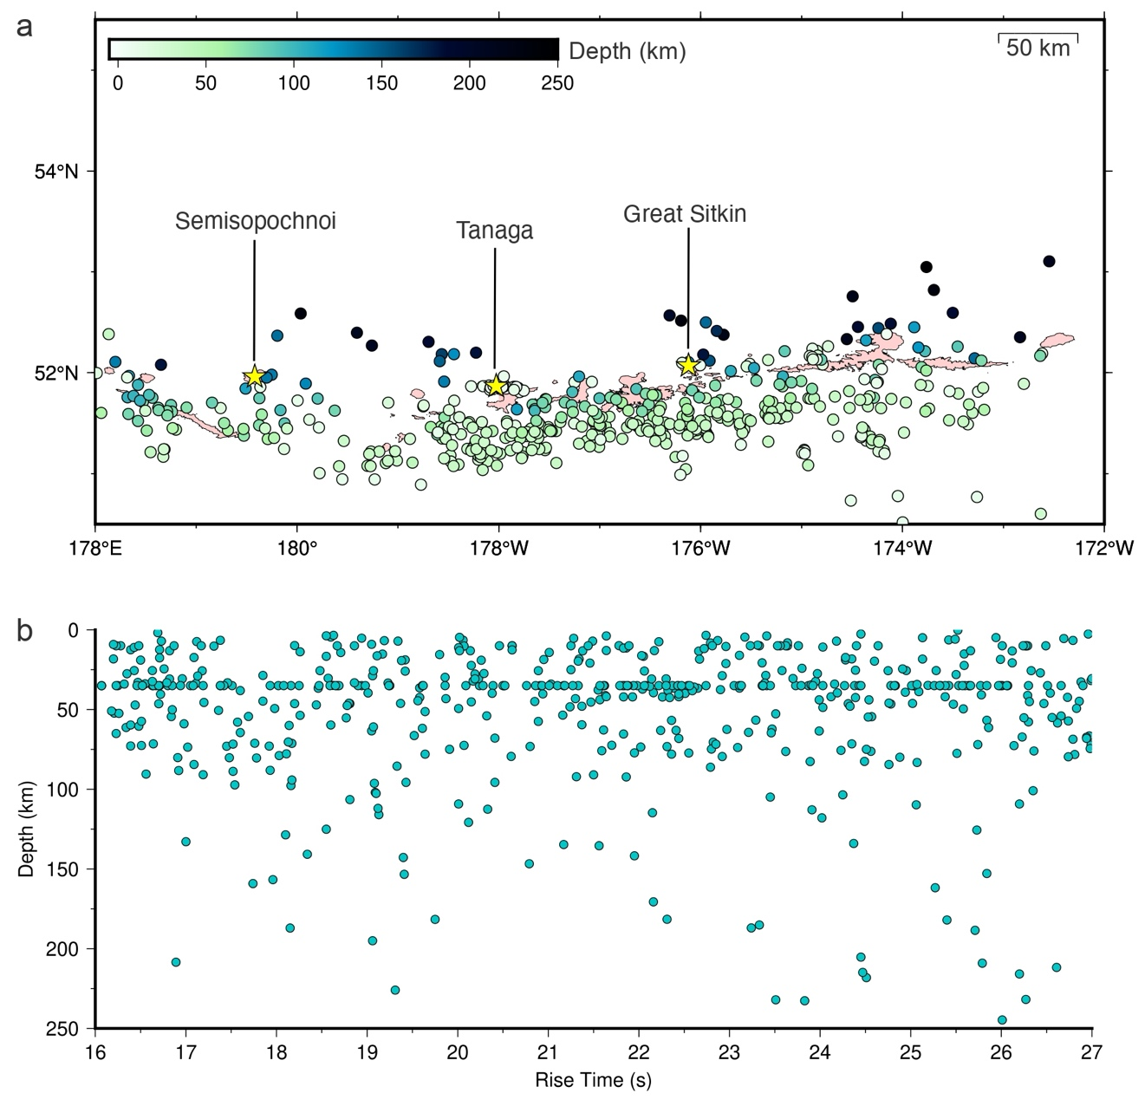
Figure S8: a) Spatial distribution of seismic events from USGS catalog along Aleutian Arc shown in Figure 1 that matched with all four types of hydroacoustic T-phases (isolated, composite PST, composite PT and paired). b) Depth of matched events with respect to rise time of T-phases.
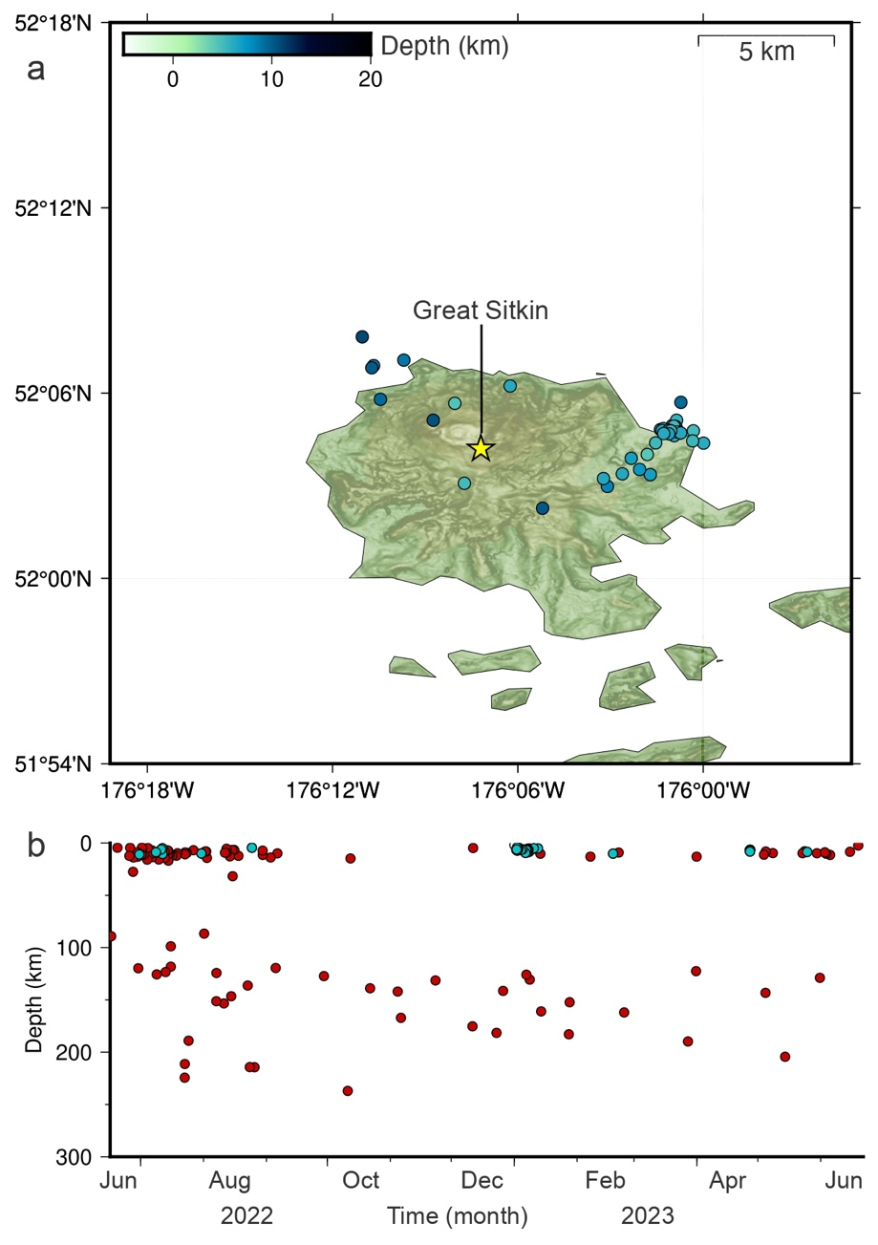
Figure S9: a) Spatial distribution of seismic events from USGS catalog near Great Sitkin Island that matched with T-phase signals. b) Temporal distribution of depth of events that matched hydroacoustically (blue) and did not match (red).

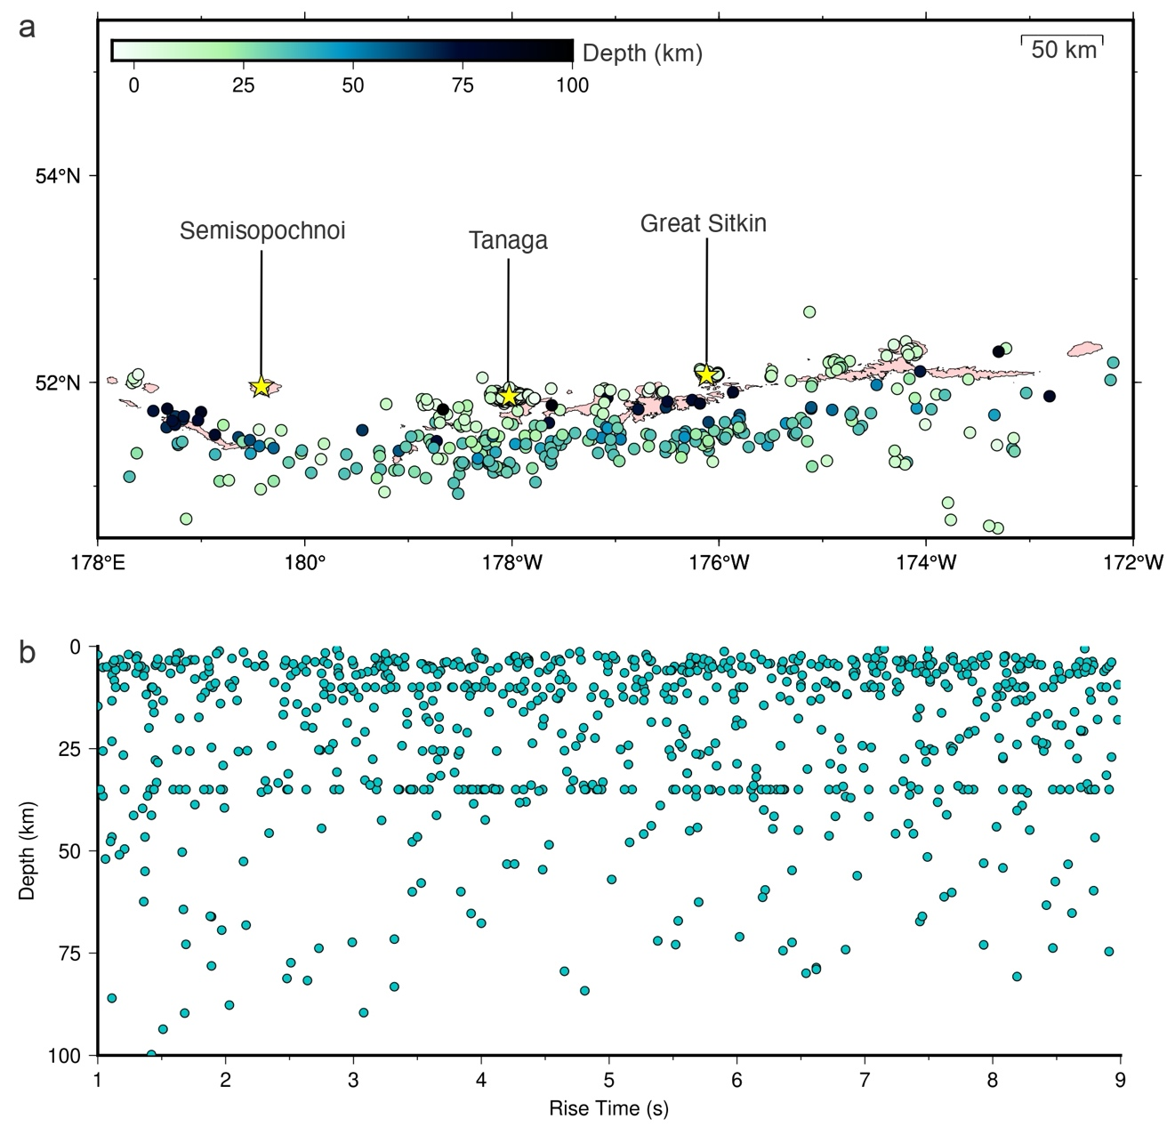
Figure S10: a) Spatial distribution of seismic events from USGS catalog along Aleutian Arc shown in Figure 1 that matched with all four types of hydroacoustic short-duration phases (impulsive I, impulsive II, doublet and uncategorized). b) Depth of matched events with respect to rise time of short-duration phases.

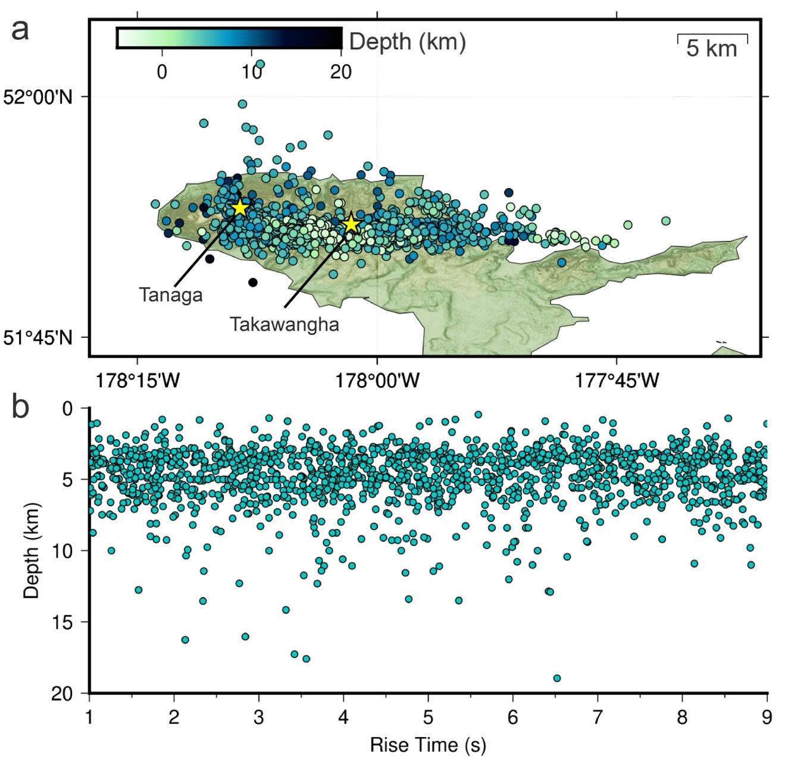
Figure S11: a) Spatial distribution of seismic events from USGS catalog near Tanaga Island shown in Figure 2a that matched with all four types of hydroacoustic short-duration phases (impulsive I, impulsive II, doublet and uncategorized). b) Depth of matched events with respect to rise time of short-duration phases.

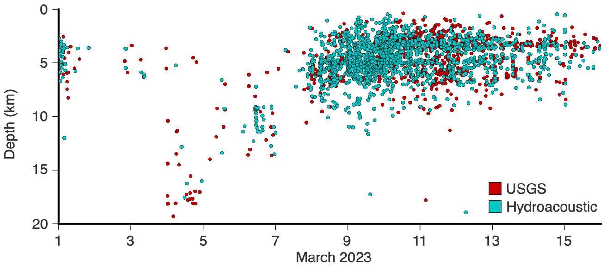
Figure S12: Depth of USGS catalog events without hydroacoustic match (red) and with hydroacoustic match near Tanaga Island (blue).

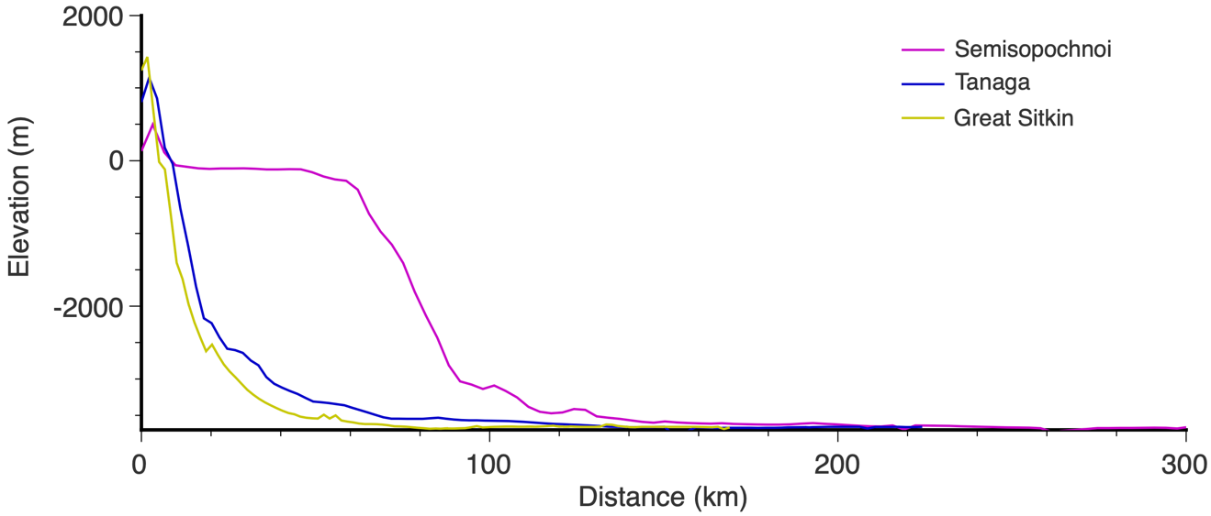
Figure S13: Elevation profiles for the paths between the hydrophone network deployed in the Bering Sea and three volcanic centers: Semisopochnoi (magenta), Tanaga (blue) and Great Sitkin (Yellow).

