Supporting Information for “Barometers behaving badly II: A critical evaluation of Cpx-only and Cpx-Liq thermobarometry in variably-hydrous arc magmas”
Penny E. Wieser^{1,2}, Adam Kent², Christy Till³
- Corresponding author: Penny_wieser@berkeley.edu. Department of Earth and Planetary Sciences, McCone Hall, UC Berkeley, 94720, USA
- College of Earth, Ocean and Atmospheric Sciences, Oregon State University, 97331, USA
- School of Earth and Space Exploration, Arizona State University, Tempe, AZ 85281, USA

Supporting figures
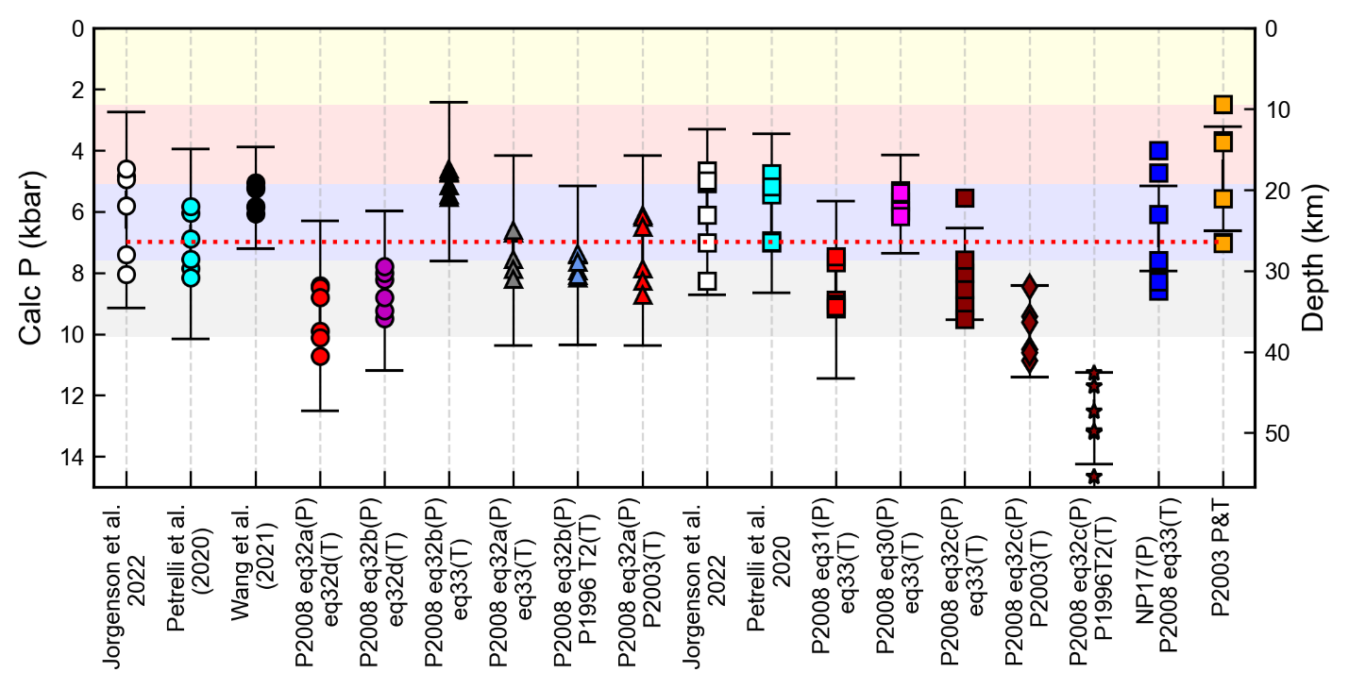
Supporting Fig. 1 – Comparison of different barometers as in Fig. 1a in the main text, but for 7 kbar experiments from Blatter et al. (2013)

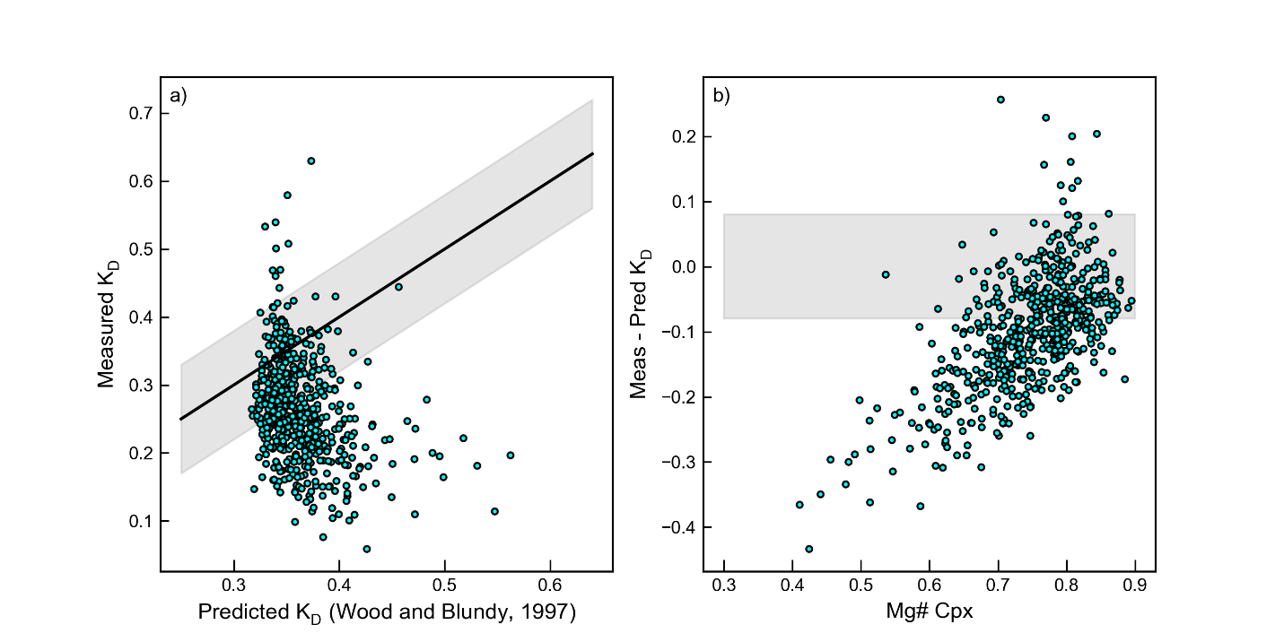
Supporting Fig. 2. Comparison of predicted and measured K_{D} using Wood and Blundy (1997). There is a clear offset between the measured and predicted K_{D} value, and the Mg# of the Cpx, with the equation performing very poorly for low Mg# Cpx.
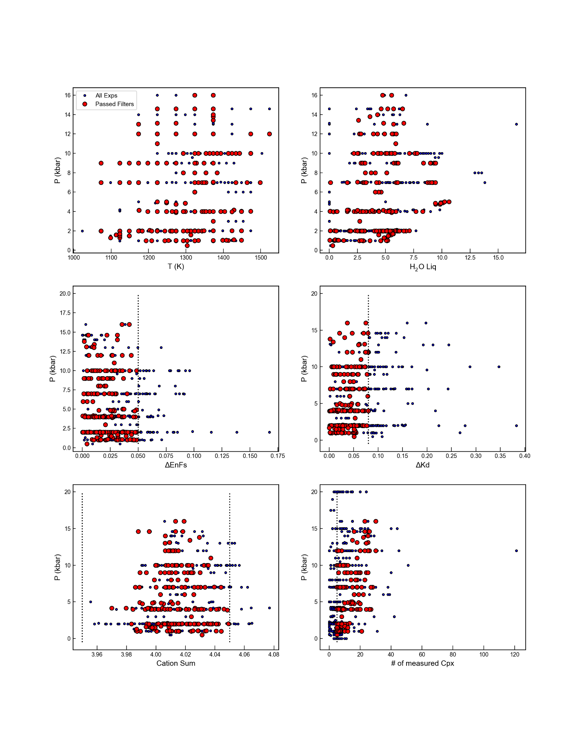
Supporting Fig. 3 – Filters applied to dataset (cut off value indicated with a dashed line). The H₂O filter removes all experiments conducted at atmospheric pressure (none of which have reported water contents).

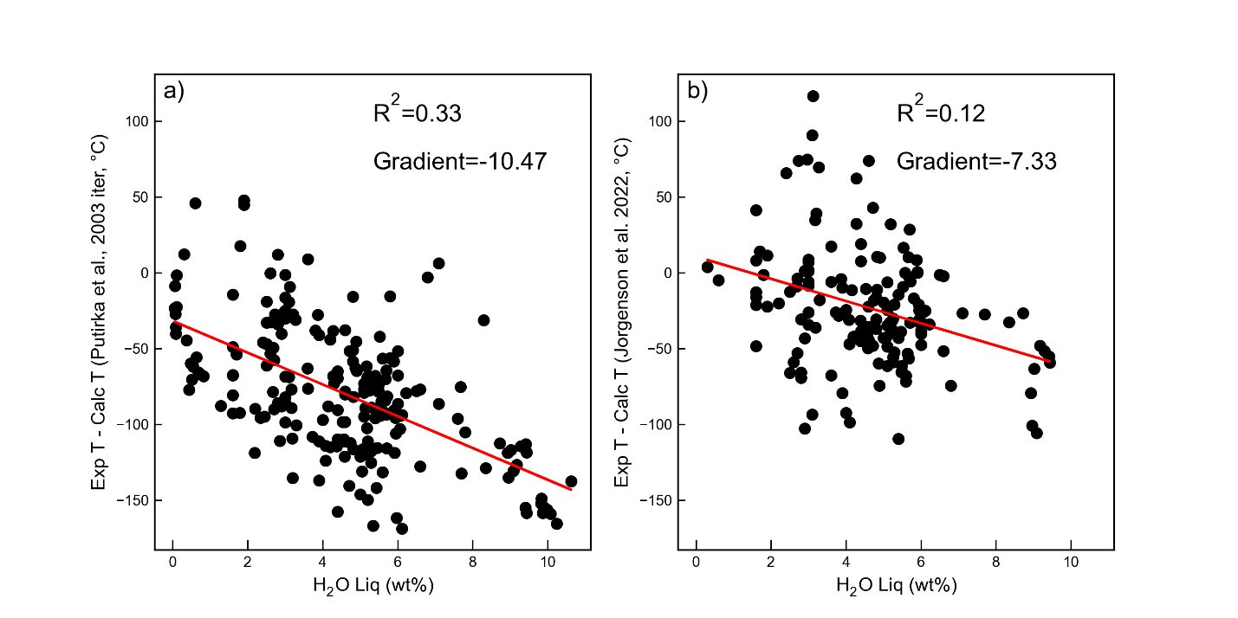
Supporting Fig. 4 – a) The discrepancy between calculated and experimental temperature iterating the thermometer and barometer of Putirka et al. (2003) increases with increasing H₂O content in the liquid. This is not surprising, given this equation has no term for H₂O, but is concerning given this equation is still used for arc magmas (see Table 1 in the main text). b) The Cpx-Liq thermometer of Jorgenson et al. (2022) also doesn’t contain a H₂O term. However, the discrepancy between experimental and calculated temperature shows a much less strong correlation with water content (lower R², less negative gradient).
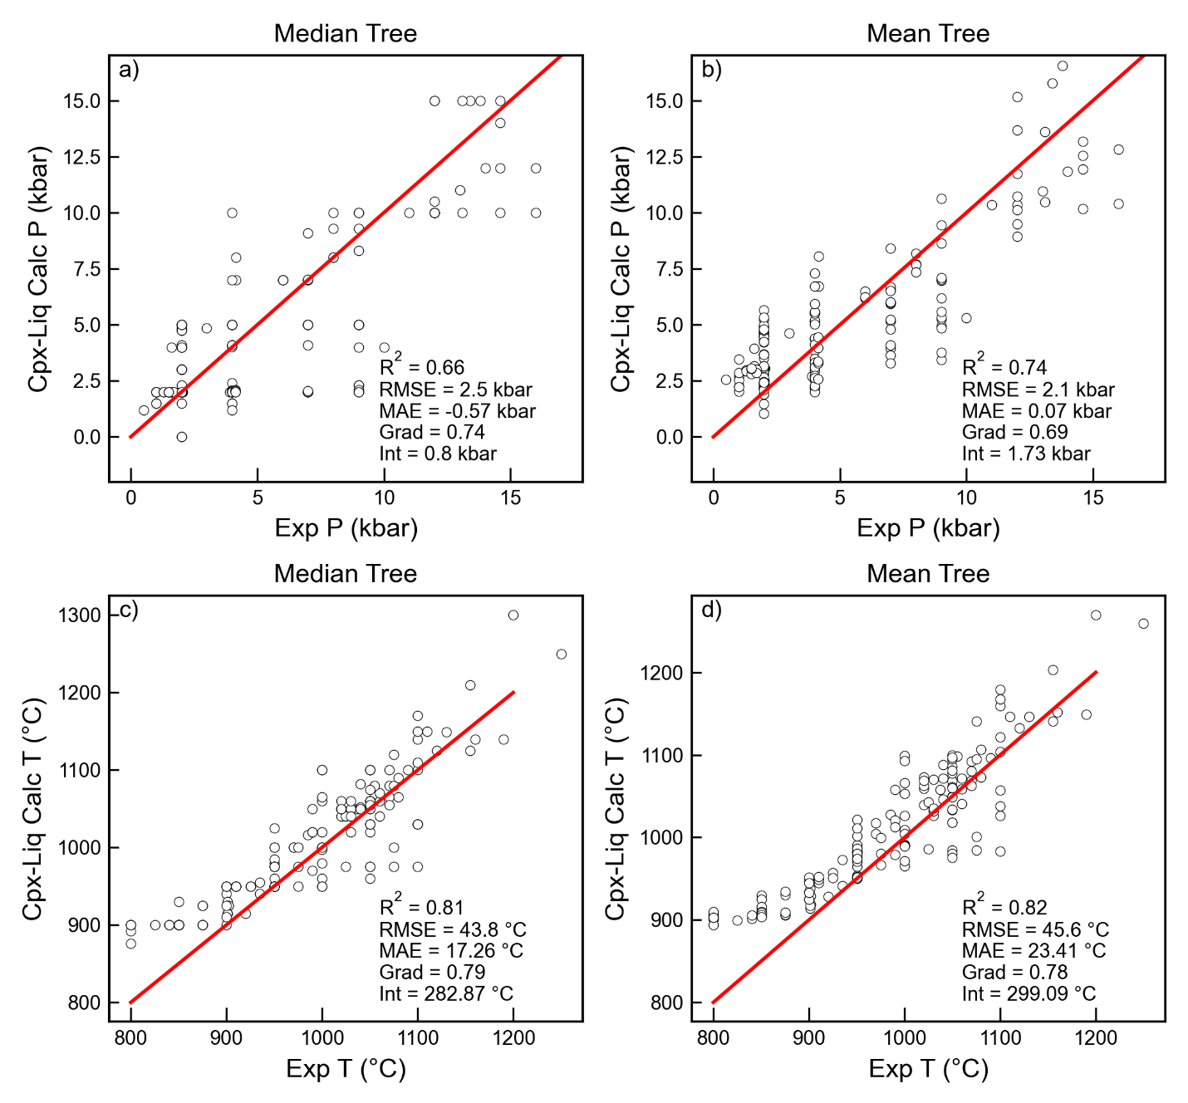
Supporting Fig 5 – Comparison of statistics using Median and mean tree for Cpx-Liq thermobarometry for Jorgenson et al. (2022).
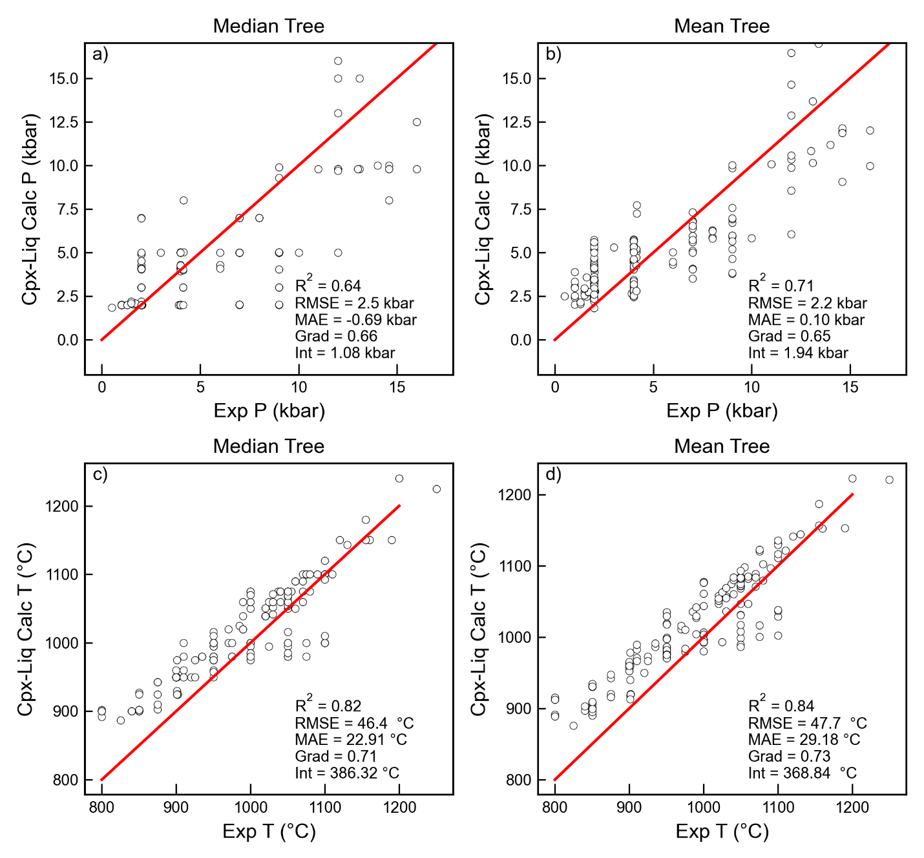
Supporting Fig. 6– Comparison of statistics using Median and mean tree for Cpx-Liq thermobarometry for Petrelli et al. (2020).
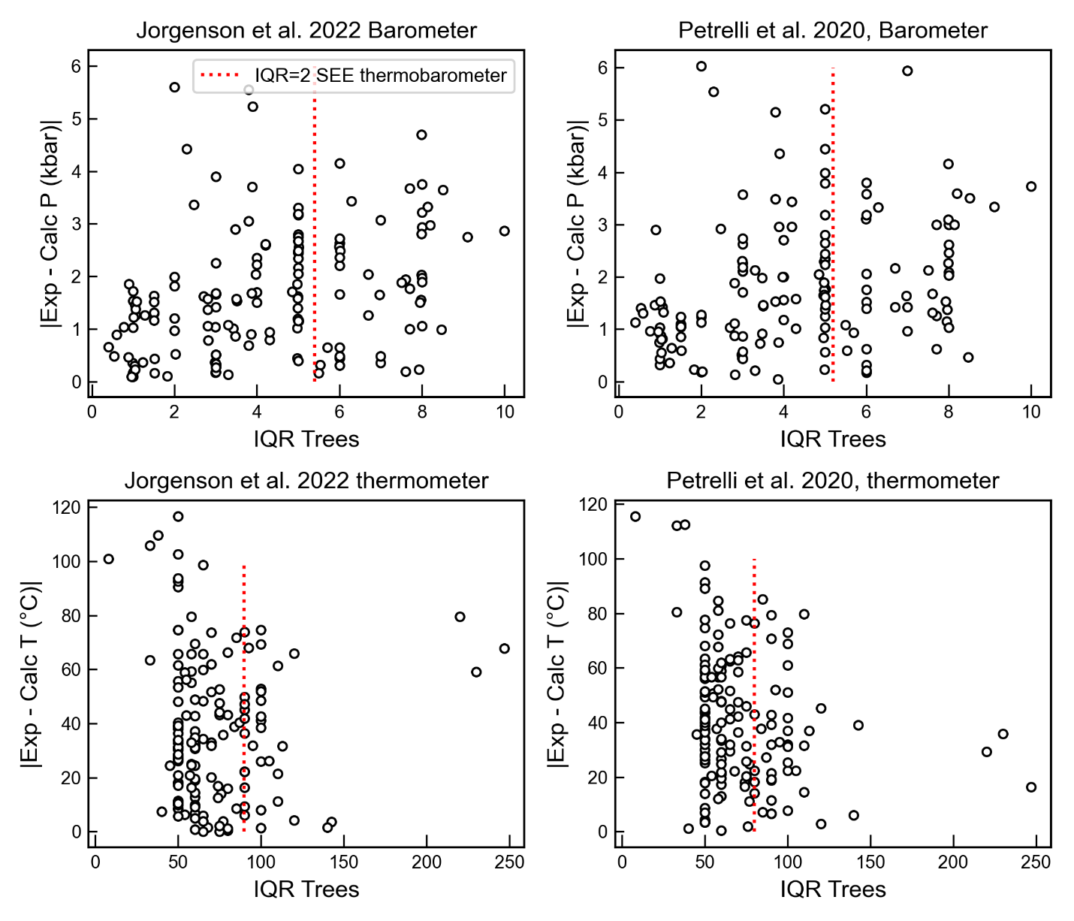
Supporting Fig. 7– Discrepancy of calculated Cpx-Liq P and T vs. the IQR of each regression tree. Jorgenson et al. suggest removing results with an IQR more than twice the stated SEE on the thermobarometer (e.g. to the right of the red dashed line). There is no clear correlation between the IQR and the absolute offset between calculated and experimental pressures and temperatures. We note that Petrelli don’t release a Cpx-only barometer, we calibrate one using their dataset and the same regression tree mechanism used for P.

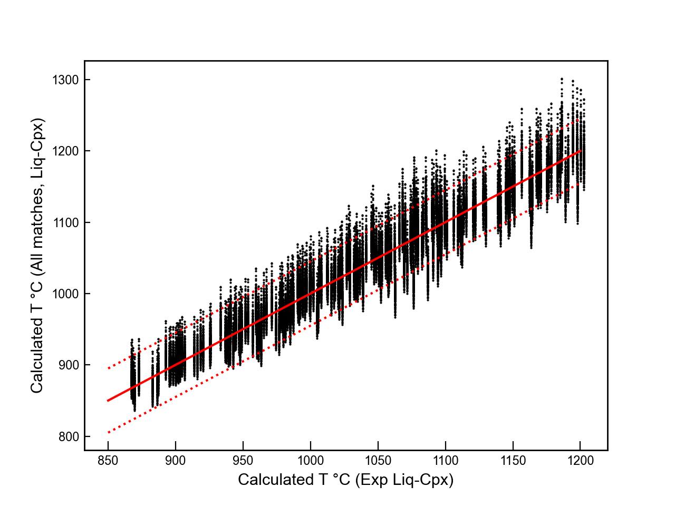
Supporting Fig 8 – Assessing the influence of the Cpx composition on the Cpx-Liq temperature. For each experimental Cpx-Liq pair we calculate the temperature using equation 33 of Putirka (2008), and plot this on the x axis. We then consider all possible Cpx-Liq matches, so each liquid gets matched to all N=194 Cpx compositions. We calculate the temperature for each of these pairs, resulting in N=194 dots sitting above each x axis coordinate. The y scatter is relatively small, the offset in calculated temperature for changing the Cpx composition is comparable to the quoted RMSE on the thermometer (shown by red dashed lines about the 1:1 red solid line). We use the average experimental pressure of the entire experimental database for all calculations.

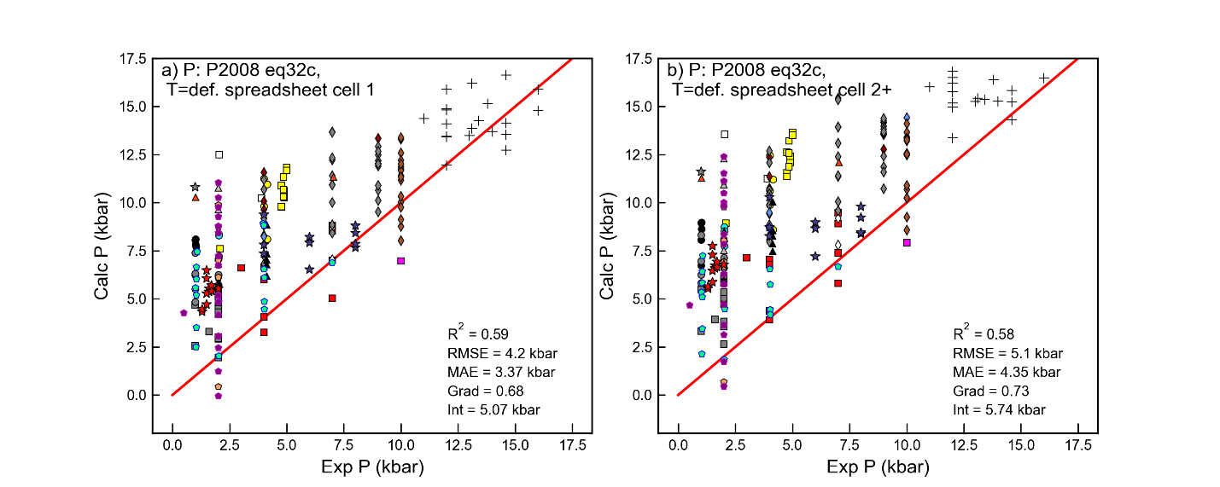
Supporting Fig. 9 – Comparing calculated and experimental pressures for the two ways Eq32c is used in the P2008 spreadsheets (the first cell vs later cells). We do not know for any given study how they dragged the cells down.
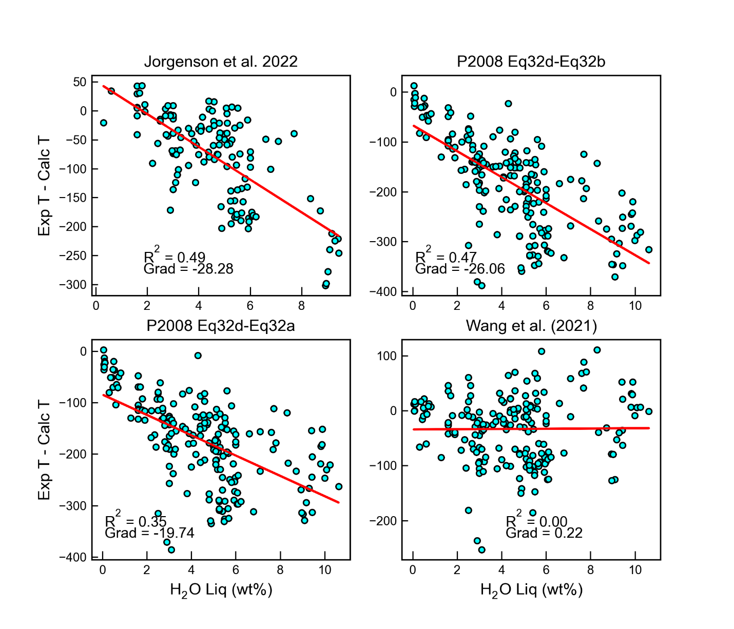
Supporting Fig 10 – Discrepancy between Cpx-only temperatures and melt water contents. Only the thermometer of Wang et al. (2021) has a term for H₂O content in the liquid.

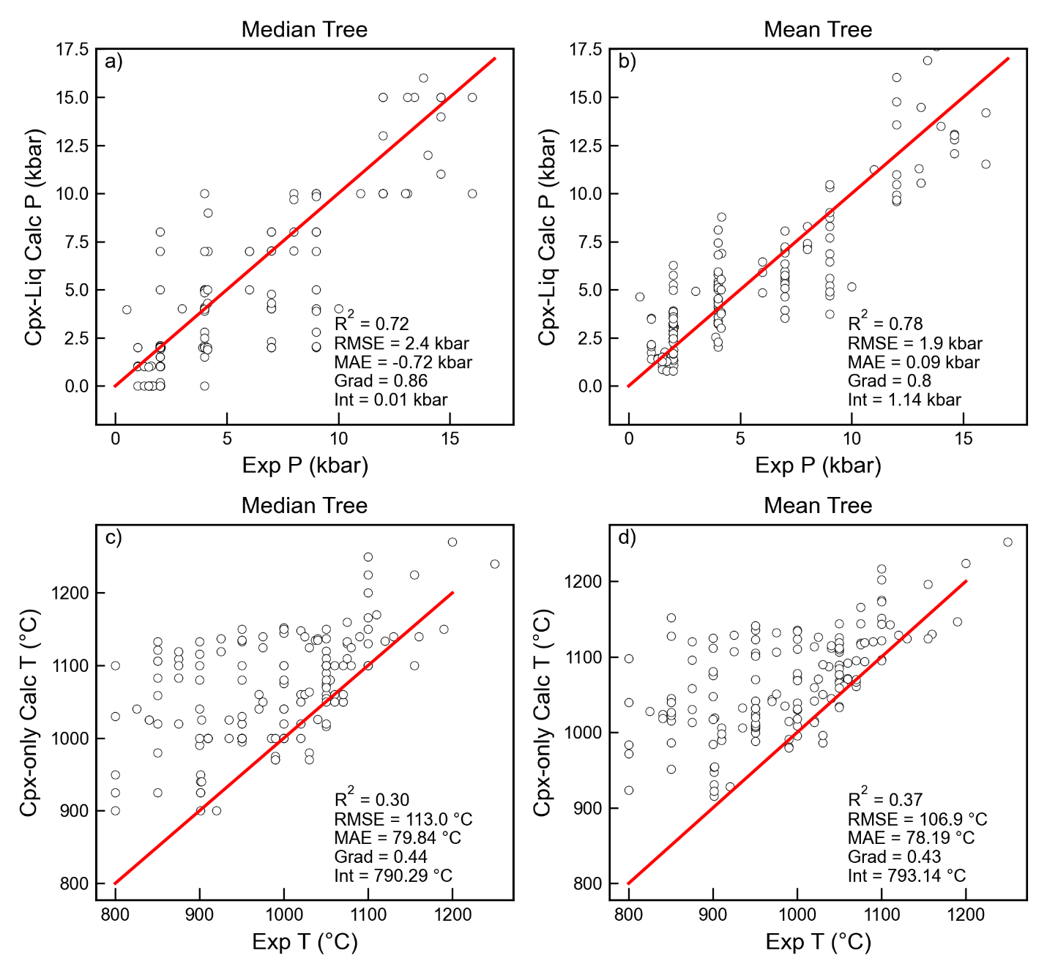
Supporting Fig 11 – Comparison of statistics using Median and mean tree for Cpx-only thermobarometry for Jorgenson et al. (2022).

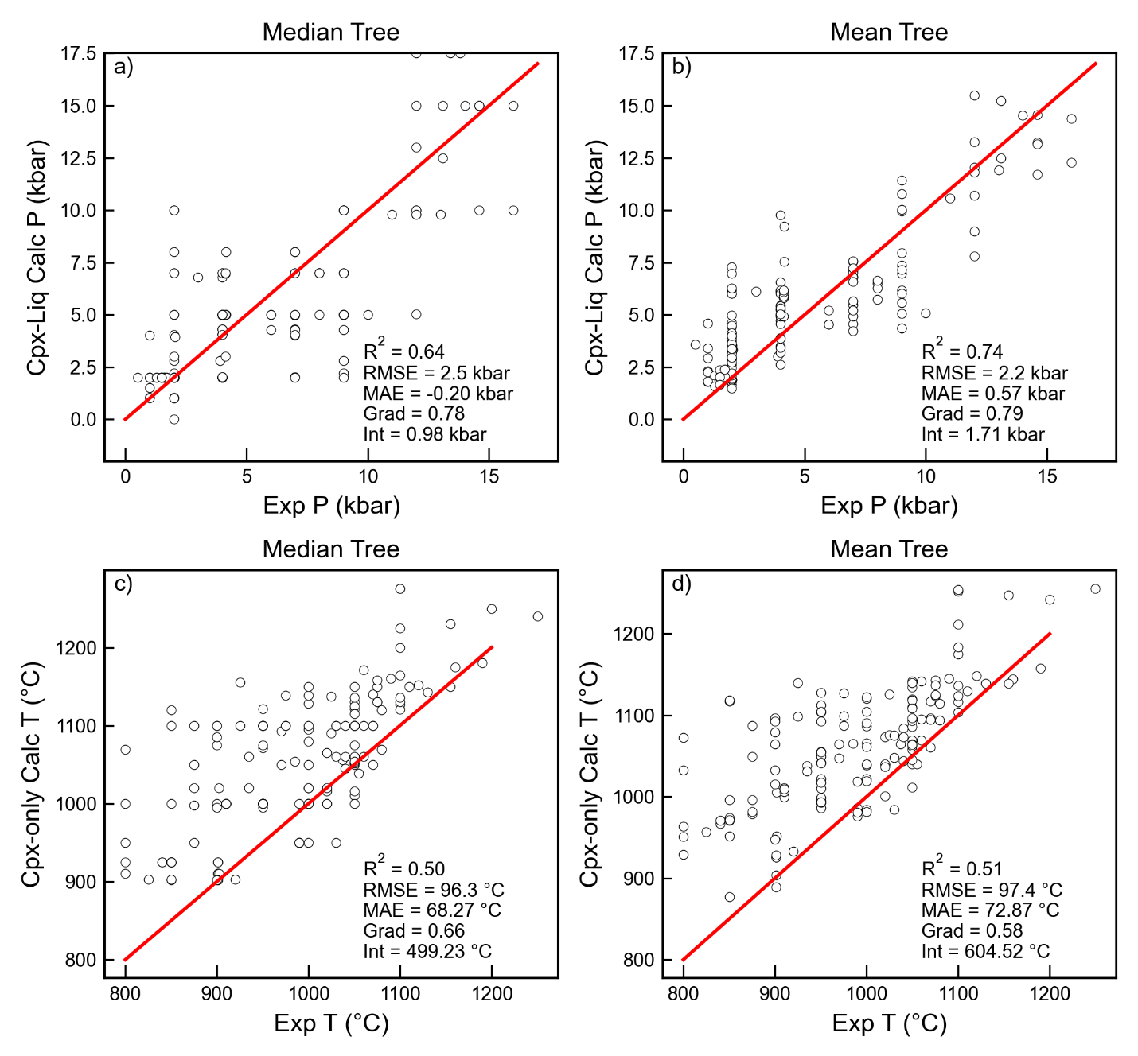
Supporting Fig. 12 – Comparison of statistics using Median and mean tree for Cpx-Liq and Cpx-only thermobarometry for Petrelli et al. (2020). No Cpx-only thermometer was officially published, we use the same regression strategy as for pressure to yield temperature.

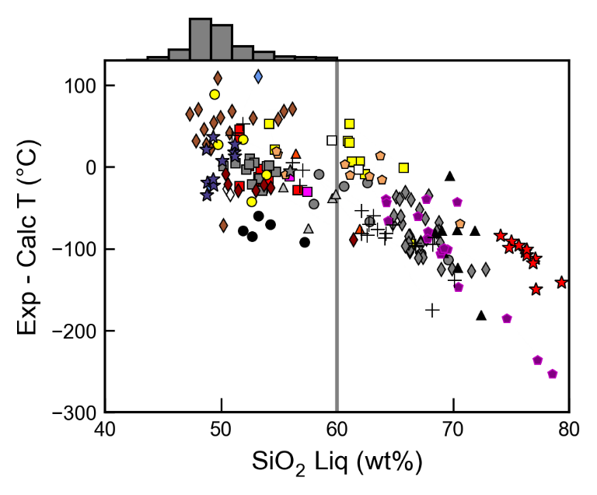
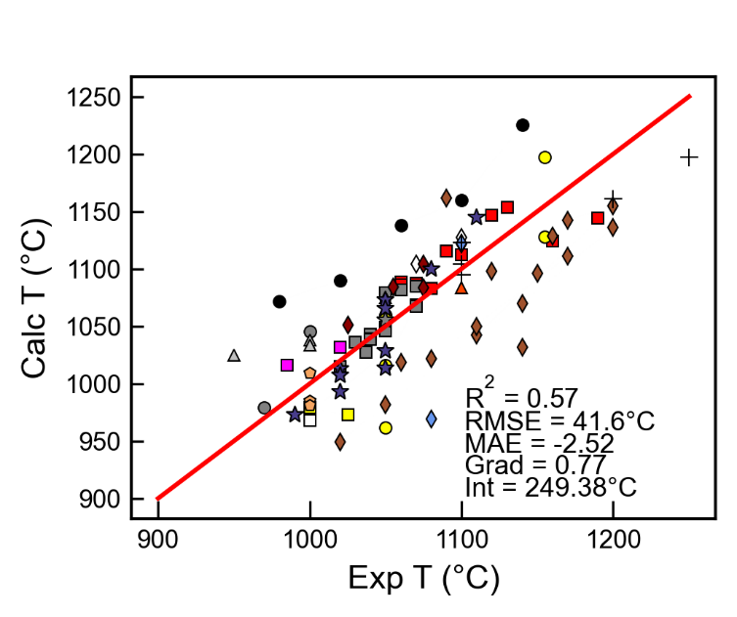
Supporting Fig 13 – Discrepancy between experimental and calculated Cpx-only temperatures using Wang et al. (2021) correlates strongly with SiO₂ when applied to Cpx grown from liquids which are more evolved than the calibration range of the model (shown by the grey histogram). Using only experiments with <60 wt% SiO2 results in a far better statistics than shown in the main text.

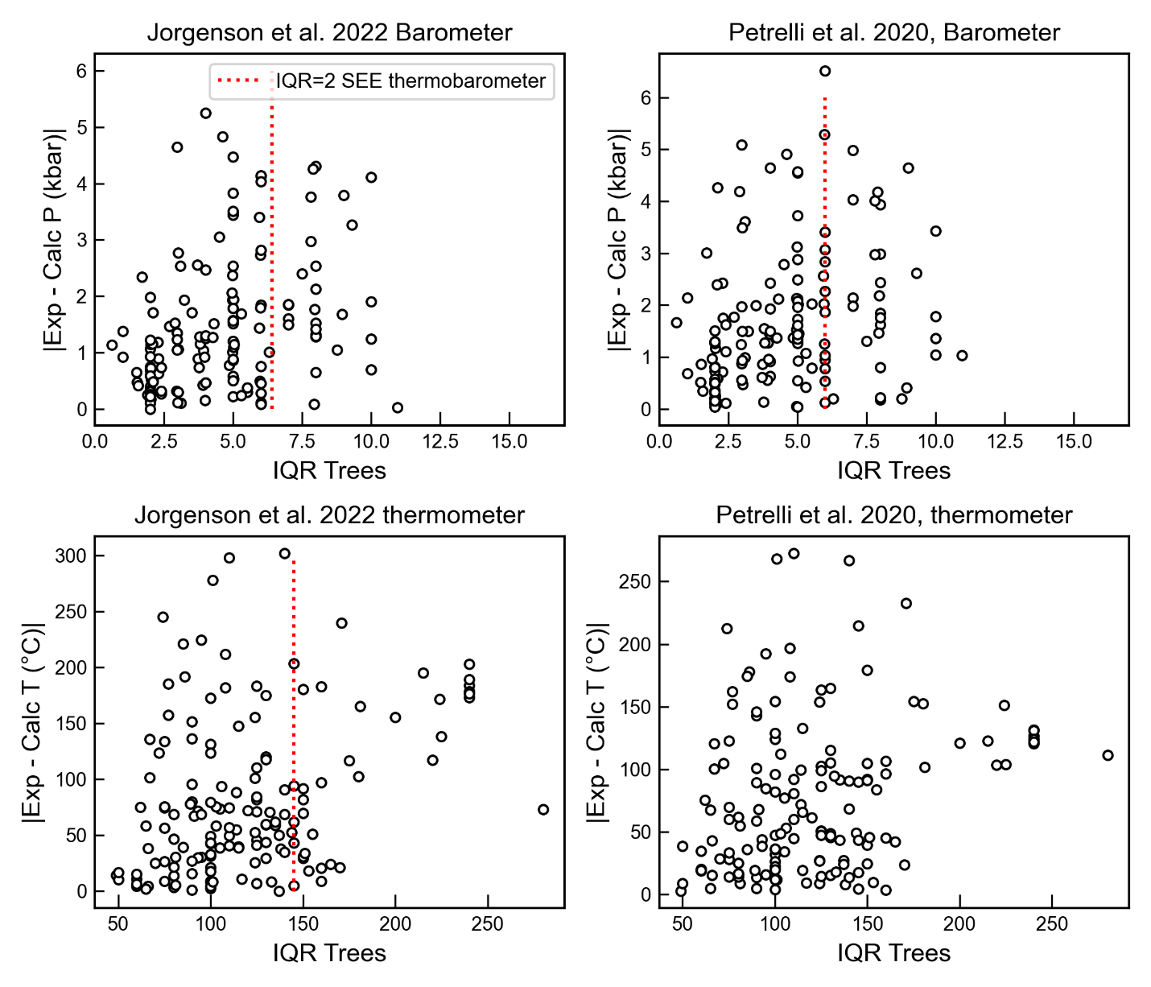
Supporting Fig. 14 – Discrepancy of calculated Cpx-only P and T vs. the IQR of each regression tree. Jorgenson et al. suggest removing results with an IQR more than twice the stated SEE on the thermobarometer (e.g. to the right of the red dashed line). There is no clear correlation between the IQR and the absolute offset between calculated and experimental pressures and temperatures. We note that Petrelli don’t release a Cpx-only barometer, we calibrate one using their dataset and the same regression tree mechanism used for P.

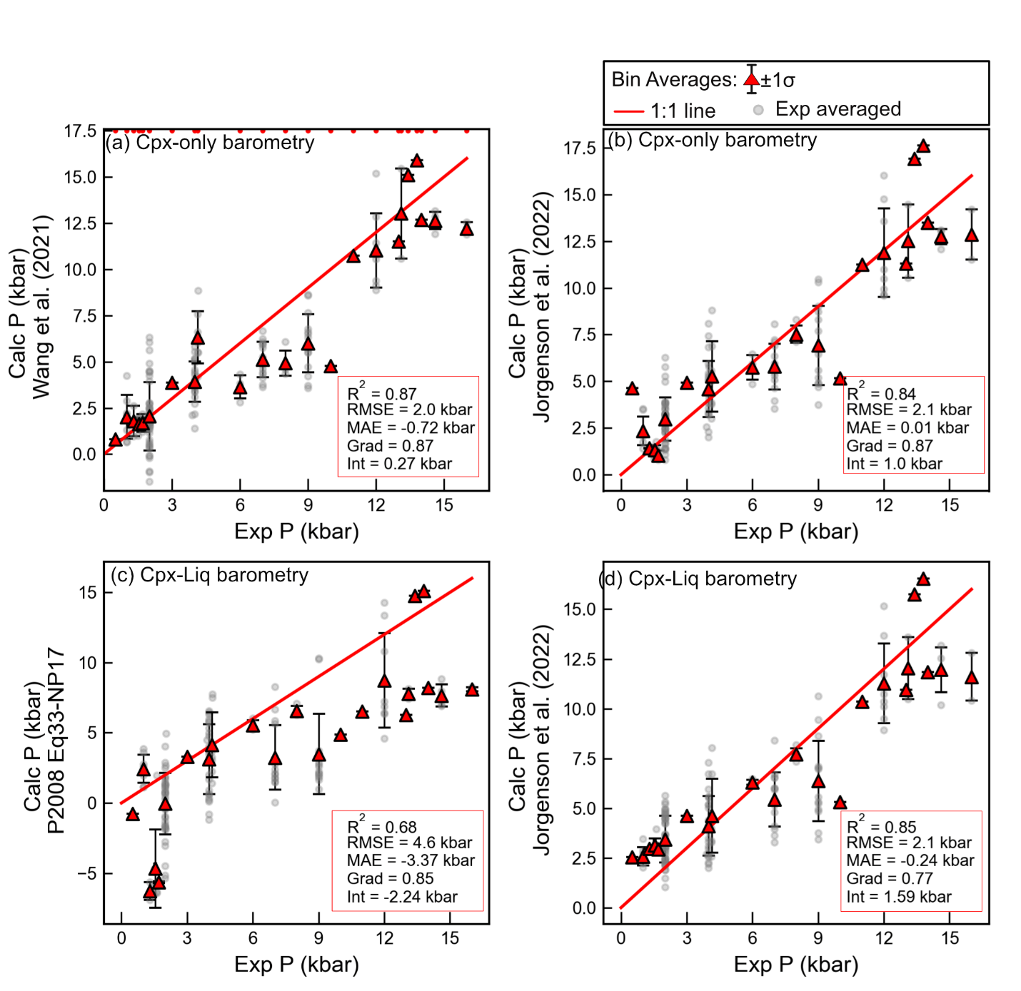
Supporting Fig. 15 – As for Fig 15 in the main text, but using bin averages even when there was only 1 experiment.

