Supplemental information.
Covariates for Spatial Analysis Candidate Models: Before assessing how [THg] and stable isotope ratios in study species tissues varied spatially across the study area, we had to control for several biological covariates that may contribute to biogeochemical variation in our sample set. In addition to improving the comparability of [THg] and stable isotope ratios among species, accounting for these factors could improve study bias as sample sizes decrease and become increasingly unbalanced in composition as spatial resolution is refined. The covariates we considered were species, length, and the interaction between species and length.
Mercury concentrations and stable isotope ratios were expected to vary among species due to differences in trophic level and foraging ecology among our sampled species. Methylmercury is the primary component of muscle tissue [THg] in these species (Trifari et al., 2024), and readily assimilates through ingestion, resulting in biomagnification of [THg] in higher trophic levels. Meanwhile, nitrogen stable isotope ratios increase with trophic level (Minagawa & Wada, 1984), while carbon stable isotope ratios are often higher in benthic and nearshore feeding species relative to pelagic species (Hobson et al., 1994; France, 1995).
In addition to differences among species, we cannot assume that [THg] or stable isotope ratios will be constant across age or size classes within species. Physiologically, mercury is ingested, assimilated, possibly biotransformed (demethylated) and eliminated from the body, thus for some tissues [THg] will change over time due to various drivers. This dynamic can result in correlations between age and [THg] for some tissues with the propensity to store mercury (Eagle-Smith et al., 2014) and these correlations between [THg] and age can be weaker in some species and stronger in others. Similarly, some fish experience ontogenetic shifts in diet, trophic position, and habitat use as they grow and their mouth gape widens (Barbeaux & Hollowed, 2018; Dalponti et al., 2018), creating likely correlations between age and both δ¹³C_{LC} and δ¹⁵N. These changes in prey selection could have positive, negative, or no effect on [THg], δ¹³C_{LC}, and/or δ¹⁵N, with the effect being variable among species, thus an interaction between species and age was considered in our models. Since age estimates were not available for our specimens, we instead used fork length for fish and mantle length for cephalopods as a proxy for age because length strongly correlates with age in both bony fishes (Eagle-Smith et al., 2014) and cephalopods (Arkhipkin, 2004). Expecting a lack of variance homogeneity in length among species, we standardized length data by centering and dividing by the standard deviation of each species’ respective length distribution. This preserved the distribution of species-specific lengths but placed these lengths on the same relative scale across species. The inclusion of length also strengthens the predictive power of our models when the species-specific length distributions varied extensively across space and time.
Covariates for Dietary Analysis Candidate Models: In our analysis of how diet relates to tissue biogeochemistry, we assume that species with similar diets are likely exposed to similar levels of mercury, all other variables being equal, which would result in similar [THg] in their tissues if assimilation processes are the same across species. To account for potential variation in baseline environmental [THg] exposure over time and space, collection year was used in all models as a random effect and region was considered as a fixed effect. The best performing spatial resolution from our spatial model selection was used to group samples regionally (see section 4.2).
As length can correlate with [THg], δ¹³C_{LC}, and δ¹⁵N values in fish and cephalopods, a length-based component was also considered in our models as a proxy for trophic structure of our sample set. Marine food webs are often size and trophic structured (Dickie et al., 1987) and trophic position correlates with [THg], δ¹³C_{LC}, and δ¹⁵N values in marine species (Campbell et al., 2005; Trifari et al., 2024), thus if length positively correlates with trophic position, larger species can have higher [THg] than smaller species and may include bioaccumulation processes that are age dependent. By including length in our models, we test whether species of similar sizes have similar [THg], δ¹³C_{LC}, and δ¹⁵N values, when dietary similarities are controlled for, or, whether trophic structure varies between foraging guilds. Additionally, it is often assumed that the consumption of larger prey as fish age and their mouth gape widens results in increases of trophic position, thus including length may account for dietary shifts with age that our grouping assessment did not capture. As different sampling areas could have different trophic dynamics, an interaction between region and length was considered. There could similarly be differences in length expectations between dietary groups, warranting the consideration of an interaction between diet group and length.
Discussion of foraging guild classification: It should be noted that we made several generalizations in our analysis of dietary compositions that could influence the interpretation of our results. By aggregating all stomach contents for a species, we remove variability in space, time, and fish maturity. Many fish experience ontogenetic changes in diet as they age, including our study species (Yang, 2003; TenBrink & Buckley, 2013). Additionally, prey items may shift locations over time, or study species may only be sampled from certain locations in certain years. It is also possible that the dietary compositions of our study species varies at small spatial resolutions, as has been noted in Atka mackerel (Rand et al., 2010; Rand & Lowe, 2011), because community diversity and structure changes from east to west across the Aleutian Islands (Coyle, 2005; Logerwell et al., 2005). Spatial imbalance of sampling may thus be influential in our compositions, and finer dietary variation may be overlooked with the regional resolution that we used. Similarly, the percent of total mass contributed by a prey item may not necessarily align with how frequent a prey item is consumed, particularly if sample sizes are small, unbalanced, or highly diverse. Because muscle [THg] are highly connected to diet, it would be well worth the investment to address the subtleties that our dietary grouping may have missed, regardless of our alignment with previous analyses.
Still, we are confident the NMDS effectively grouped species by their dietary similarities. While the NMDS aligned with descriptive methods more commonly used in stomach content studies, vectorization of content items onto the NMDS offered a clear representation of what individual content items drive dietary similarity compared to other methods. For instance, position on the y-axis of our NMDS was highly influenced by fish species as stomach content items and this largely drove dissimilarity within our pelagic zooplankton and benthic consumer groups, where walleye pollock and yellow Irish lord were slightly separated from the other species of their respective groups. Similarly, while our piscivore group had largely similar diets, the influence of benthic invertebrates slightly drives dissimilarity between flounder species and Pacific cod, further supporting findings that benthic species may be contributing to mercury patterns Pacific cod.

References
Arkhipkin A.I., 2004. Diversity in growth and longevity inshort-lived animals: squid of the
suborder Oegopsina. Marine and Freshwater Research. 55, 341-355. https://doi.org/10.1071/MF03202.

Barbeaux S.J. and Hollowed A.B., 2018. Ontogeny matters: climate variability and effects on
fish distribution in the eastern Bering Sea. Fisheries Oceanography. 27, 1-15. https://doi.org/10.1111/fog.12229.

Campbell L.M., Norstrom R.J., Hobson K.A., Muir D.C.G., Backus S., Fisk A.T., 2005. Mercury
and other trace elements in a pelagic Arctic marine food web (Northwater Polynya, Baffin Bay). Science of the Total Environment. 351-352, 247-263. https://doi.org/10.1016/j.scitotenv.2005.02.043.

Coyle K. 2005. Zooplankton distribution, abundance and biomass relative to water masses in
eastern and central Aleutian Island passes. Fisheries Oceanography. 14:77-92. https://doi.org/10.1111/j.1365-2419.2005.00367.x.

Dalponti G., Guariento R.D., Caliman A., 2018. Hunting high or low: body size drives trophic
position among and within marine predators. Marine Ecology Progress Series. 597, 39-46. https://doi.org/10.3354/meps12584.

Dickie L.M., Kerr S.R., Boudreau P.R., 1987. Size-dependent processes underlying regularities
in ecosystem structure. Ecological Monographs. 57, 233-250. https://doi.org/10.2307/2937082.

Eagle-Smith C.A., Willacker Jr. J.J., Flanagan-Pritz C.M., 2014. Mercury in fishes from 21
National Parks in the western United States – inter- and intra-park variation in concentrations and ecological risk. US Geological Survey. Open File Report 2014-2105.

France R.L., 1995. Carbon-13 enrichment in benthic compared to planktonic algae: foodweb
implications. Marine Ecology Progress Series. 124, 307-312.

Hobson K.A., Piatt J.F., Pitocchelli J., 1994. Using stable isotopes to determine seabird trophic
relationships. Journal of Animal Ecology. 63, 786-798.

Logerwell EA, Aydin K, Barbeaux S, Brown E, Conners ME, Lowe S, Orr JW, Ortiz I, Reuter R,
Spencer P. 2005. Geographic patterns in the demersal ichthyofauna of the Aleutian Islands. Fisheries Oceanography. 14:93-112. https://doi.org/10.1111/j.1365-2419.2005.00366.x.

Rand KM, Beauchamp DA, Lowe SA. 2010. Longitudinal growth differences and the influence
of diet quality on Atka mackerel of the Aleutian Islands, Alaska: using a bioenergetics model to explore underlying mechanisms. Marine and Coastal Fisheries: Dynamics, Management and Ecosystem Science. 2:362-374. https://doi.org/10.1577/C09-046.1.

Rand KM, Lowe SA. 2011. Defining essential fish habitat for Atka mackerel with respect to
feeding within and adjacent to Aleutian Islands trawl exclusion zones. Marine and Coastal Fisheries: Dynamics, Management and Ecosystem Science. 3:21-31. https://doi.org/10.1080/15427951.2010.558402.

Rand KM, McDermott S, Logerwell E, Matta ME, Levine M, Bryan DR, Spies IB, Loomis T.
2019. Higher aggregation of key prey species associated with diet and abundance of the Steller sea lion Eumetopias jubatus across the Aleutian Islands. Marine and Coastal Fisheries: Dynamics, Management and Ecosystem Science. 11:472-486. https://doi.org/10.1002/mcf2.10096.

TenBrink TT and Buckley TW. 2013. Life-history aspects of the yellow Irish lord (Hemilepidotus
jordani) in the eastern Bering Sea and Aleutian Islands. Northwestern Naturalist. 94:126-136. https://doi.org/10.1898/12-33.1.

Yang MS. 2003. Food habits of important groundfishes in the Aleutian Islands in 1994 and
1997. US Dept of Commerce. AFSC Processed Report.

Table S1: The number of samples collected in each subregion considered. Total and species-specific amounts shown.

 | West | East |  | 543 | 542 | 541 |  | Near | Buldir | Rat | Petrel | Delarof | Tanaga | Atka | Seguam
Total | 953 | 508 |  | 691 | 529 | 241 |  | 210 | 481 | 153 | 109 | 166 | 101 | 99 | 142
Aleutian squid  (Berryteuthis magister) | 88 | 32 |  | 88 | 22 | 10 |  | 25 | 63 | 0 | 0 | 22 | 0 | 10 | 0
Arrowtooth flounder  (Atheresthes stomias) | 60 | 54 |  | 56 | 32 | 26 |  | 16 | 40 | 1 | 3 | 21 | 7 | 21 | 5
Atka mackerel  (Pleurogrammus monopterygius) | 184 | 97 |  | 172 | 56 | 53 |  | 43 | 129 | 0 | 12 | 20 | 24 | 0 | 53
Darkfin sculpin  (Malacoccottus zonurus) | 52 | 45 |  | 44 | 53 | 0 |  | 1 | 43 | 0 | 8 | 45 | 0 | 0 | 0
Kamchatka flounder  (Atheresthes evermanni) | 13 | 42 |  | 6 | 29 | 20 |  | 6 | 0 | 1 | 6 | 22 | 0 | 20 | 0
Northern rockfish  (Sebastes polyspinis) | 94 | 46 |  | 61 | 57 | 22 |  | 16 | 45 | 21 | 12 | 0 | 24 | 17 | 5
Pacific cod  (Gadus macrocephalus) | 119 | 50 |  | 80 | 64 | 25 |  | 38 | 42 | 20 | 19 | 0 | 25 | 0 | 25
Pacific ocean perch  (Sebastes alutus) | 105 | 34 |  | 44 | 79 | 16 |  | 0 | 44 | 37 | 24 | 10 | 8 | 10 | 6
Pacific octopus  (Enteroctopus dofleini) | 28 | 0 |  | 19 | 9 | 0 |  | 2 | 17 | 9 | 0 | 0 | 0 | 0 | 0
Northern rock sole  (Lepidopsetta polyxystra) | 41 | 23 |  | 0 | 41 | 23 |  | 0 | 0 | 40 | 1 | 0 | 0 | 0 | 23
Walleye pollock  (Gadus chalcogrammus) | 89 | 46 |  | 65 | 47 | 23 |  | 31 | 34 | 0 | 24 | 20 | 3 | 21 | 2
Yellow Irish lord  (Hemilepidotus jordani) | 80 | 39 |  | 56 | 40 | 23 |  | 32 | 24 | 24 | 0 | 6 | 10 | 0 | 23
Table S2: The number of samples collected each in subregion, by year. Total (bold) and species-specific amounts shown.

 | West | East |  | 543 | 542 | 541 |  | Near | Buldir | Rat | Petrel | Delarof | Tanaga | Atka | Seguam
2011 | 37 | 68 |  |  | 75 | 30 |  |  |  |  | 37 |  | 38 |  | 30
Arrowtooth flounder | 2 | 9 |  |  | 6 | 5 |  |  |  |  | 2 |  | 4 |  | 5
Atka mackerel | 6 | 11 |  |  | 11 | 6 |  |  |  |  | 6 |  | 5 |  | 6
Kamchatka flounder | 3 |  |  |  | 3 |  |  |  |  |  | 3
Northern rockfish | 6 | 11 |  |  | 12 | 5 |  |  |  |  | 6 |  | 6 |  | 5
Pacific cod | 7 | 13 |  |  | 19 | 1 |  |  |  |  | 7 |  | 12 |  | 1
Pacific ocean perch | 6 | 14 |  |  | 14 | 6 |  |  |  |  | 6 |  | 8 |  | 6
Northern rock sole | 1 | 3 |  |  | 1 | 3 |  |  |  |  | 1 |  |  |  | 3
Walleye pollock | 6 | 5 |  |  | 9 | 2 |  |  |  |  | 6 |  | 3 |  | 2
Yellow Irish lord |  | 2 |  |  |  | 2 |  |  |  |  |  |  |  |  | 2
2013 | 201 | 210 |  | 169 | 64 | 178 |  |  | 169 | 32 |  | 32 |  | 99 | 79
Aleutian Squid | 20 | 10 |  | 20 |  | 10 |  |  | 20 |  |  |  |  | 10
Arrowtooth Flounder | 22 | 21 |  | 22 |  | 21 |  |  | 22 |  |  |  |  | 21
Atka Mackerel | 20 | 18 |  | 20 |  | 18 |  |  | 20 |  |  |  |  |  | 18
Darkfin Sculpin | 19 |  |  | 19 |  |  |  |  | 19
Kamchatka Flounder |  | 42 |  |  | 22 | 20 |  |  |  |  |  | 22 |  | 20
Northern Rockfish | 21 | 17 |  | 21 |  | 17 |  |  | 21 |  |  |  |  | 17
Pacific Cod | 15 | 20 |  | 15 |  | 20 |  |  | 15 |  |  |  |  |  | 20
Pacific Ocean Perch | 20 | 20 |  | 20 | 10 | 10 |  |  | 20 |  |  | 10 |  | 10
Pacific Octopus | 17 |  |  | 11 | 6 |  |  |  | 11 | 6
Rock Sole | 20 | 20 |  |  | 20 | 20 |  |  |  | 20 |  |  |  |  | 20
Walleye Pollock | 21 | 21 |  | 21 |  | 21 |  |  | 21 |  |  |  |  | 21
Yellow Irish Lord | 6 | 21 |  |  | 6 | 21 |  |  |  | 6 |  |  |  |  | 21

Table S2 (continued): The number of samples collected in each subregion, by year. Species-specific amounts shown.

 | West | East |  | 543 | 542 | 541 |  | Near | Buldir | Rat | Petrel | Delarof | Tanaga | Atka | Seguam
2014 | 283 | 135 |  | 169 | 226 | 23 |  | 103 | 66 | 114 |  | 112 |  |  | 23
Aleutian Squid | 28 | 20 |  | 28 | 20 |  |  | 25 | 3 |  |  | 20
Arrowtooth Flounder | 9 | 20 |  | 9 | 20 |  |  | 9 |  |  |  | 20
Atka Mackerel | 72 | 39 |  | 72 | 20 | 19 |  | 26 | 46 |  |  | 20 |  |  | 19
Darkfin Sculpin |  | 32 |  |  | 32 |  |  |  |  |  |  | 32
Kamchatka Flounder | 5 |  |  | 5 |  |  |  | 5
Northern Rockfish | 21 |  |  |  | 21 |  |  |  |  | 21
Pacific Cod | 55 | 4 |  | 35 | 20 | 4 |  | 18 | 17 | 20 |  |  |  |  | 4
Pacific Ocean Perch | 33 |  |  |  | 33 |  |  |  |  | 33
Pacific Octopus | 2 |  |  |  | 2 |  |  |  |  | 2
Rock Sole | 20 |  |  |  | 20 |  |  |  |  | 20
Walleye Pollock | 10 | 20 |  | 10 | 20 |  |  | 10 |  |  |  | 20
Yellow Irish Lord | 28 |  |  | 10 | 18 |  |  | 10 |  | 18
2015 | 164 | 10 |  | 164 |  | 10 |  | 105 | 59 |  |  |  |  |  | 10
Aleutian Squid | 20 |  |  | 20 |  |  |  |  | 20
Arrowtooth Flounder | 8 |  |  | 8 |  |  |  | 7 | 1
Atka Mackerel | 55 | 10 |  | 55 |  | 10 |  | 17 | 38 |  |  |  |  |  | 10
Darkfin Sculpin | 1 |  |  | 1 |  |  |  | 1
Kamchatka Flounder | 1 |  |  | 1 |  |  |  | 1
Northern Rockfish | 16 |  |  | 16 |  |  |  | 16
Pacific Cod | 20 |  |  | 20 |  |  |  | 20
Pacific Octopus | 2 |  |  | 2 |  |  |  | 2
Walleye Pollock | 21 |  |  | 21 |  |  |  | 21
Yellow Irish Lord | 20 |  |  | 20 |  |  |  | 20
Table S2 (continued): The number of samples collected in each subregion, by year. Species-specific amounts shown.

 | West | East |  | 543 | 542 | 541 |  | Near | Buldir | Rat | Petrel | Delarof | Tanaga | Atka | Seguam
2020 | 134 | 22 |  | 94 | 62 | 94 |  |  | 94 | 7 | 33 | 9 | 13
Aleutian Squid | 6 |  |  | 6 |  |  |  |  | 6
Arrowtooth Flounder | 7 |  |  | 6 | 1 |  |  |  | 6 | 1
Atka Mackerel | 18 | 6 |  | 12 | 12 |  |  |  | 12 |  | 6 |  | 6
Darkfin Sculpin | 18 | 3 |  | 12 | 9 |  |  |  | 12 |  | 6 | 3
Kamchatka Flounder | 4 |  |  |  | 4 |  |  |  |  | 1 | 3
Northern Rockfish | 18 | 6 |  | 12 | 12 |  |  |  | 12 |  | 6 |  | 6
Pacific Cod | 10 | 1 |  | 10 | 1 |  |  |  | 10 |  |  |  | 1
Pacific Ocean Perch | 22 |  |  | 12 | 10 |  |  |  | 12 | 4 | 6
Pacific Octopus | 2 |  |  | 1 | 1 |  |  |  | 1 | 1
Walleye Pollock | 19 |  |  | 13 | 6 |  |  |  | 13 |  | 6
Yellow Irish Lord | 10 | 6 |  | 10 | 6 |  |  |  | 10 |  |  | 6
2021 | 134 | 63 |  | 95 | 102 | 95 |  | 2 | 93 |  | 39 | 13 | 50
Aleutian Squid | 14 | 2 |  | 14 | 2 |  |  |  | 14 |  |  | 2
Arrowtooth Flounder | 12 | 4 |  | 11 | 5 |  |  |  | 11 |  | 1 | 1 | 3
Atka Mackerel | 13 | 13 |  | 13 | 13 |  |  |  | 13 |  |  |  | 13
Darkfin Sculpin | 14 | 10 |  | 12 | 12 |  |  |  | 12 |  | 2 | 10
Northern Rockfish | 12 | 12 |  | 12 | 12 |  |  |  | 12 |  |  |  | 12
Pacific Cod | 12 | 12 |  |  | 24 |  |  |  |  |  | 12 |  | 12
Pacific Ocean Perch | 24 |  |  | 12 | 12 |  |  |  | 12 |  | 12
Pacific Octopus | 5 |  |  | 5 |  |  |  |  | 5
Walleye Pollock | 12 |  |  |  | 12 |  |  |  |  |  | 12
Yellow Irish Lord | 16 | 10 |  | 16 | 10 |  |  | 2 | 14 |  |  |  | 10

Table S3: Candidate models and corresponding hypotheses describing [THg], δ¹³C_{LC}, and δ¹⁵N values. Year is a random effect in all models but is only shown in the first row. Longitude trend is only assessed for stable isotope ratio variability.

Regional Models | Hypotheses Assessed
= $Region_{Longitude}+γYear$ | Biogeochemical variation is best described by a continuous longitudinal trend. Year is random effect.
= $Region_{AmPass}$ | Grouping samples east and west of Amchitka Pass best describes biogeochemical variation.
= $Region_{FMZ}$ | Grouping samples by FMZ best describes biogeochemical variation.
= $Region_{Island}$ | Grouping samples by island groups separated by deep water oceanic passes best describes biogeochemical variation.
Covariate Models | Hypotheses Supported
= $Region_{i}$ | Biogeochemical composition varies only by region.
=$Length_{STD}+Region_{i}$ | The relationship between biogeochemical composition and standardized length is the same everywhere, but stable isotope ratios differ by region after controlling for length.
=$Species+Region_{i}$ | Biogeochemical composition varies among species and by region, but species-specific differences are the same across regions.
= $Length_{STD}+Species+Region_{i}$ | Biogeochemical composition follows a common standardized length trend with species-specific intercepts and varies by region.
= $Length_{STD}*Species+Region_{i}$ | Biogeochemical composition follows species-specific standardized length trends and by region.

Table S4: Candidate models and corresponding hypotheses they support in assessment of how foraging guild influences [THg], δ¹³C_{LC}, and δ¹⁵N patterns. Year is a random effect in all models but is only shown in the first row.

Candidate Models | Hypotheses Supported
= $γYear$ | Biogeochemical compositions only randomly vary over time
= $Diet$ | Biogeochemical composition varies by similar diets.
= $Diet+ Region_{best}$ | Biogeochemical composition varies by similar diet and region.
= $Length_{STD}+ Diet$ | Biogeochemical composition varies by length and similar diet.
= $Length_{STD}* Diet$ | Biogeochemical composition varies by similar diet and length. Length mediates diet effects.
= $Length_{STD}+ Region_{best}+ Diet$ | Biogeochemical composition varies by length, among regions and by similar diet.
= $Length_{STD}*Region_{best}+ Diet$ | Biogeochemical composition varies by similar diet and length. Region mediates length effects.
= $Diet*Length_{STD}+Region_{best}* Length_{STD}$ | All tested covariates impact biogeochemical composition, with region mediating length effects and length mediating diet effects.

Table S5: Sampling summary for each study species, shown in rank ascending order of [THg]. Mean ± SD presented. See section 4.1 for the number of samples removed for analysis of stable isotope ratios because of lipid content bias.

Species |  | N  (Total) | Length  (cm) | [THg]  (µg/g WW) | δ¹⁵N  (‰ vs AIR) | δ¹³C_{LC}  (‰ vs VPDB
Armhook squid | (Berryteuthis magister) | 120 | 23.4 ± 2.7 | 0.04 ± 0.02 | 10.9 ± 0.7 | -19.9 ± 0.8
Atka mackerel | (Pleurogrammus monopterygius) | 281 | 37.9 ± 4.1 | 0.05 ± 0.03 | 9.5 ± 0.7 | -20.6 ± 0.8
Pacific octopus | (Enteroctopus dofleini) | 28 | 16.6 ± 4.1 | 0.09 ± 0.03 | 11.1 ± 0.8 | -18.6 ± 0.5
Pacific ocean perch | (Sebastes alutus) | 139 | 36.3 ± 4.2 | 0.10 ± 0.13 | 10.4 ± 0.7 | -20.3 ± 0.6
Walleye pollock | (Gadus chalcogrammus) | 135 | 52.0 ± 6.7 | 0.11 ± 0.15 | 10.6 ± 0.9 | -20.1 ± 1.0
Northern rockfish | (Sebastes polyspinis) | 140 | 32.2 ± 3.5 | 0.11 ± 0.10 | 10.6 ± 0.6 | -20.0 ± 0.7
Arrowtooth flounder | (Atheresthes stomias) | 114 | 52.8 ± 15.9 | 0.18 ± 0.14 | 11.7 ± 0.8 | -19.2 ± 0.8
Kamchatka flounder | (Atheresthes evermanni) | 55 | 46.1 ± 15.9 | 0.23 ± 0.20 | 12.2 ± 0.8 | -18.9 ± 0.9
Pacific cod | (Gadus macrocephalus) | 169 | 64.9 ± 17.0 | 0.23 ± 0.14 | 12.9 ± 0.7 | -18.7 ± 0.6
Northern rock sole | (Lepidopsetta polyxystra) | 64 | 39.5 ± 2.2 | 0.24 ± 0.12 | 10.5 ± 0.6 | -18.7 ± 0.7
Darkfin sculpin | (Malacoccottus zonurus) | 97 | 19.9 ± 4.0 | 0.25 ± 0.12 | 13.0 ± 0.9 | -18.8 ± 0.6
Yellow Irish lord | (Hemilepidotus jordani) | 119 | 38.4 ± 6.0 | 0.42 ± 0.36 | 12.4 ± 0.6 | -18.7 ± 1.0

Table S6: Significance values of pairwise comparisons between estimated marginal mean δ¹³C_{LC} values at the community level, divided by oceanic passes. Blue shading indicates p < 0.05, grey shading indicates p > 0.05.

 | Near | Buldir | Rat | Petrel | Delarof | Tanaga | Atka | Seguam
Near
Buldir | <0.001
Rat | <0.001 | <0.001
Petrel | <0.001 | >0.1 | <0.001
Delarof | <0.001 | <0.001 | <0.001 | <0.001
Tanaga | <0.001 | <0.001 | <0.001 | <0.001 | >0.1
Atka | <0.001 | <0.001 | <0.001 | <0.001 | >0.05 | >0.05
Seguam | <0.001 | <0.001 | <0.001 | <0.001 | >0.1 | >0.1 | >0.1

Table S7: Significance values of pairwise comparisons between estimated marginal mean δ¹⁵N values at the community level, divided by oceanic passes. Blue shading indicates p < 0.01, red shading indicates 0.01 < p < 0.05, and grey shading indicates p > 0.05.

 | Near | Buldir | Rat | Petrel | Delarof | Tanaga | Atka | Seguam
Near
Buldir | <0.001
Rat | <0.001 | >0.1
Petrel | >0.1 | <0.01 | <0.01
Delarof | <0.001 | <0.01 | >0.1 | <.0001
Tanaga | <0.001 | <0.001 | >0.1 | <.0001 | >0.1
Atka | <0.001 | >0.1 | >0.1 | <0.1 | <0.1 | <0.05
Seguam | <0.001 | <0.001 | <0.01 | <.0001 | >0.1 | >0.1 | <0.001

Table S8: Significance values from pairwise comparison of [THg] estimated marginal means in the Island Group model using Tukey adjusted p-values. Blue shading indicates p < 0.01, red shading indicates 0.01 < p < 0.05, and grey shading indicates p > 0.05.

 | Near | Buldir | Rat | Petrel | Delarof | Tanaga | Atka | Seguam
Near
Buldir | <0.001
Rat | <0.001 | <0.01
Petrel | >0.1 | <0.01 | <0.001
Delarof | >0.1 | <0.001 | <0.001 | >0.1
Tanaga | >0.1 | >0.1 | <0.01 | >0.1 | >0.1
Atka | <0.001 | <0.001 | <0.001 | <0.001 | <.0001 | <0.001
Seguam | <0.001 | <0.001 | <0.001 | <0.001 | <0.05 | <0.001 | >0.1

Table S9: Information criterion model selection ($∆$AIC from best model) predicting [THg], integrating detrended δ¹³C_{LC}.and δ¹⁵N values (C_{res} and N_{res}). δ¹³C_{LC}.and δ¹⁵N values were detrended of island group, standardized length, species fixed effects and collection year random effects.

 | $∆$AIC
Island + Length x Species + C_{res} + N_{res} | ---
Island + Length x Species + C_{res} x N_{res} | 1.1
Island + Length x Species + N_{res} | 15.5
Island + Length x Species + C_{res} | 53.1
Island + Length x Species | 86.0

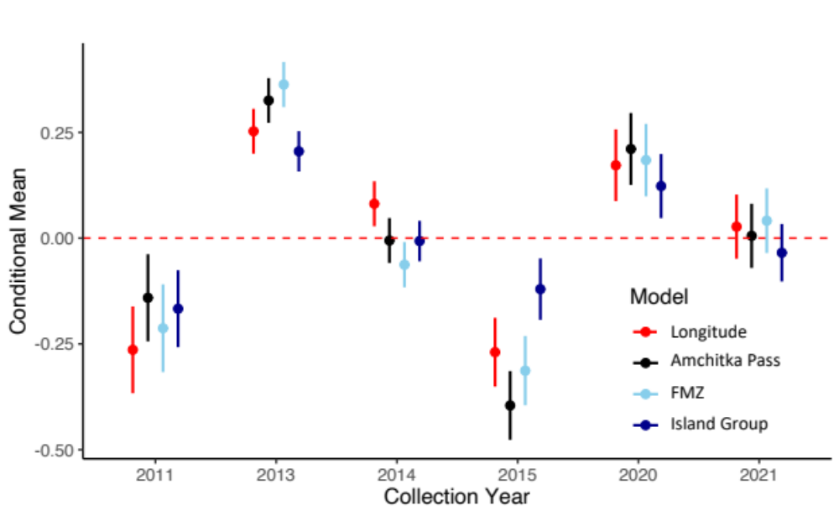

Figure S1: Coefficient estimates (mean and 95% confidence interval) of the random effect of collection year on δ¹³C_{LC} values for the best candidate model of each spatial resolution. A red dashed line is added at 0 as an interpretation aid.

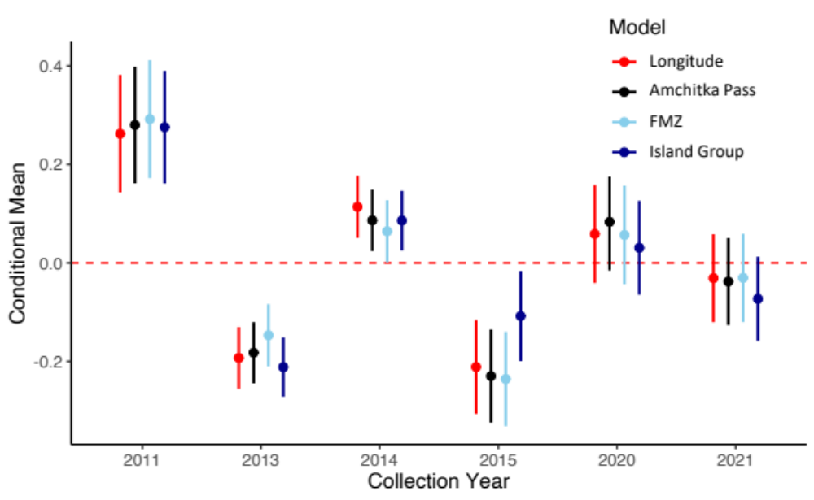

Figure S2: Coefficient estimates (mean and 95% confidence interval) for the random effect of collection year on δ¹⁵N values for the best candidate model of each spatial resolution. A red dashed line is added at 0 as an interpretation aid.

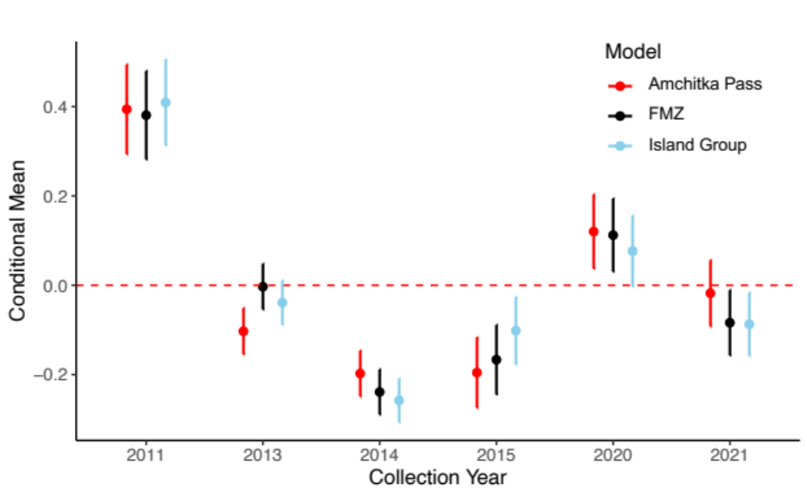
Figure S3: Random effect coefficients with 95% confidence interval for each best candidate model of different spatial resolution predicting log[THg]. A red dashed line is added at 0 as an interpretation aid.

